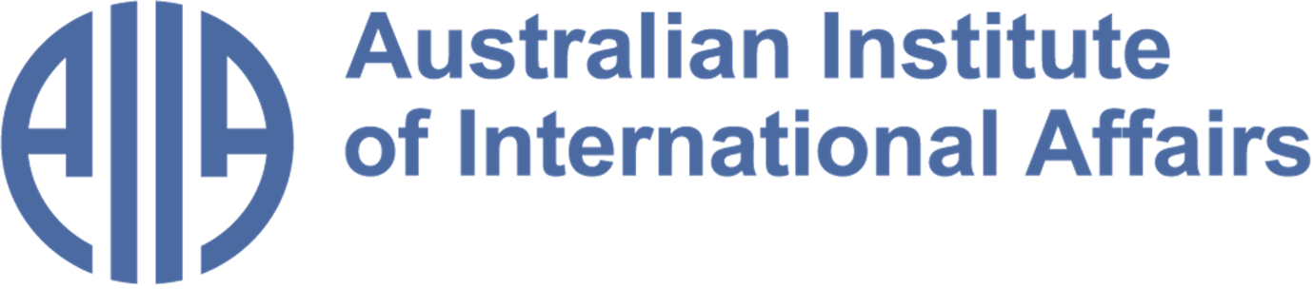

The Australian Institute of International Affairs New South Wales welcomes you to issue 111 of:



From the Councillors

​​Twice a month, some of our Councillors and interns share a selection of articles, analytical pieces, videos, and podcasts about what is happening in international affairs. This week Ian Lincoln explores miscalculations in US intelligence on Iran’s regional reach and the risks to global oil flows in its current war on Iran. Jocelyn Chey reveals the hidden relationship between the wind and international relations.
Disclaimer: The views expressed below by councillors and interns are their own. The Australian Institute of International Affairs New South Wales does not take policy positions.

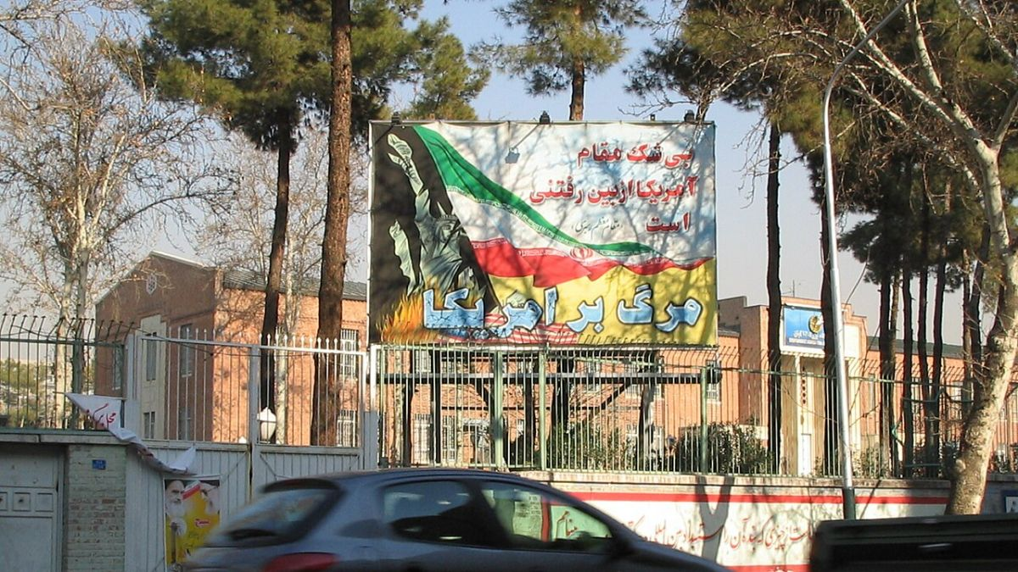

Stalemate in Iran
Amid the flood of analyses of the current US war against Iran, Monica Duffy Toft, Professor of International Politics at the Fletcher School, Tufts University, draws lessons from previous engagements by the US and its allies in Vietnam, Afghanistan, Ukraine and now Venezuela.
She comments that, in the absence of diplomatic relations since 1979 and hence of an American embassy in Tehran, the US has relied heavily for intelligence on CIA networks “of questionable quality” and on Israeli assets with their own country's interests in mind. She considers that the US did not anticipate that Iran had rebuilt and dispersed significant military capacity since 2025 and would strike neighbors across the region, including Azerbaijan, widening the conflict well beyond the Persian Gulf and undermining US strategic interests with India and Sri Lanka. She notes that that the US greatly underestimated the disruption of world oil distribution resulting from Iran’s capacity to block the Straits of Hormuz, now causing world-wide concerns.
Toft assesses that Iran does not need to defeat the US conventionally: it needs only to raise costs, exploit chokepoints and wait for a fracture among US allies and domestic political opposition to force either a fake US declaration of victory or a genuine US withdrawal.
She concludes with a quote from Australian historian Geoffrey Blainey that wars start when both sides hold incompatible beliefs about power, and end only when reality forces those beliefs to align. In the case of Iran, there is nothing to suggest that this situation is approaching.
Image credit: Former US embassy in Tehran, Fabienkhan via Wikimedia Commons

This article was selected by Ian Lincoln, President of AIIA NSW since 2017. Ian was in the Department of Foreign Affairs for 33 years including postings in Asia, Africa, Europe and the Pacific. He was later an appellate member of the Refugee Review Tribunal and has worked in a number of community organisations.

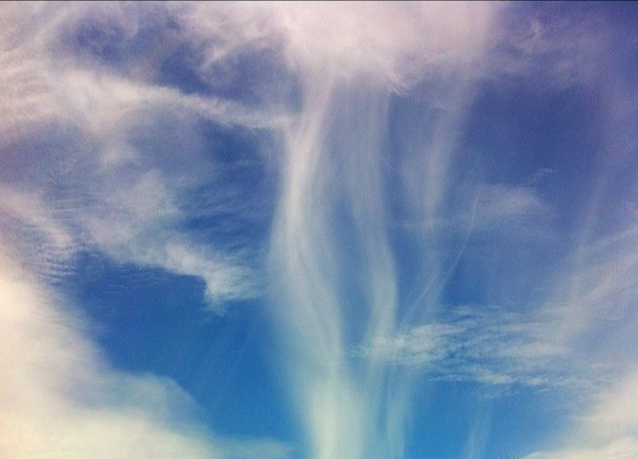

The Winds of Change
I can’t tell why I chose Simon Winchester’s latest book The Breath of the Gods: The History and Future of the Wind (William Collins 2026) to take as reading matter when I went to a conference in Wellington, New Zealand, in February, except that I have enjoyed other books by this author. Perhaps subconsciously it was because Wellington is the world’s windiest city, and indeed a storm blew up and closed the airport the day after I left.
You may wonder what wind has got to do with international relations. The answer is: a lot. In the historic Age of Sail, of course, there were famous naval battles won or lost by the wind. More recently, in World War Two, the date of D-Day was determined by an accurate weather forecast and Tokyo was destroyed by the firestorm that erupted after American bombing raids. In the new millennium, meteorologists have to monitor terrestrial and upper atmosphere weather because this affects flights and satellite orbits. Natural disasters, which are of increasing intensity and severity due to climate change, also have the potential to threaten international relations.
Winchester’s book is crammed with more wind facts and case studies to educate and amuse the reader.
Image credit: Brave Heart on Flickr

This book was selected by Jocelyn Chey AM. Jocelyn is an Adjunct Professor at the Australia-China Relations Institute, University of Technology Sydney, Visiting Professor at the University of Sydney and an Adjunct Professor at the Australia-China Institute for Arts and Culture at Western Sydney University. She was previously a senior officer in the Department of Foreign Affairs and Trade. Jocelyn is a Fellow of the Australian Institute of International Affairs.

From the Interns

In addition to our Councillors' recommendations, we invite our interns to share with you what they have found insightful or interesting in the world of international affairs. This week, Federico Canas Velasco explores how One Nation's unprecedented surge reflects a sweeping global realignment of the radical right, alongside Trump, Farage, and Meloni. Paolo Lini explores the future of drone warfare amid the ongoing wars in Ukraine and Iran. Kimmy Kwok reflects on the US Immigration Department's unjust crackdown on pregnant migrant women.
Disclaimer: The views expressed below by councillors and interns are their own. The Australian Institute of International Affairs New South Wales does not take policy positions.

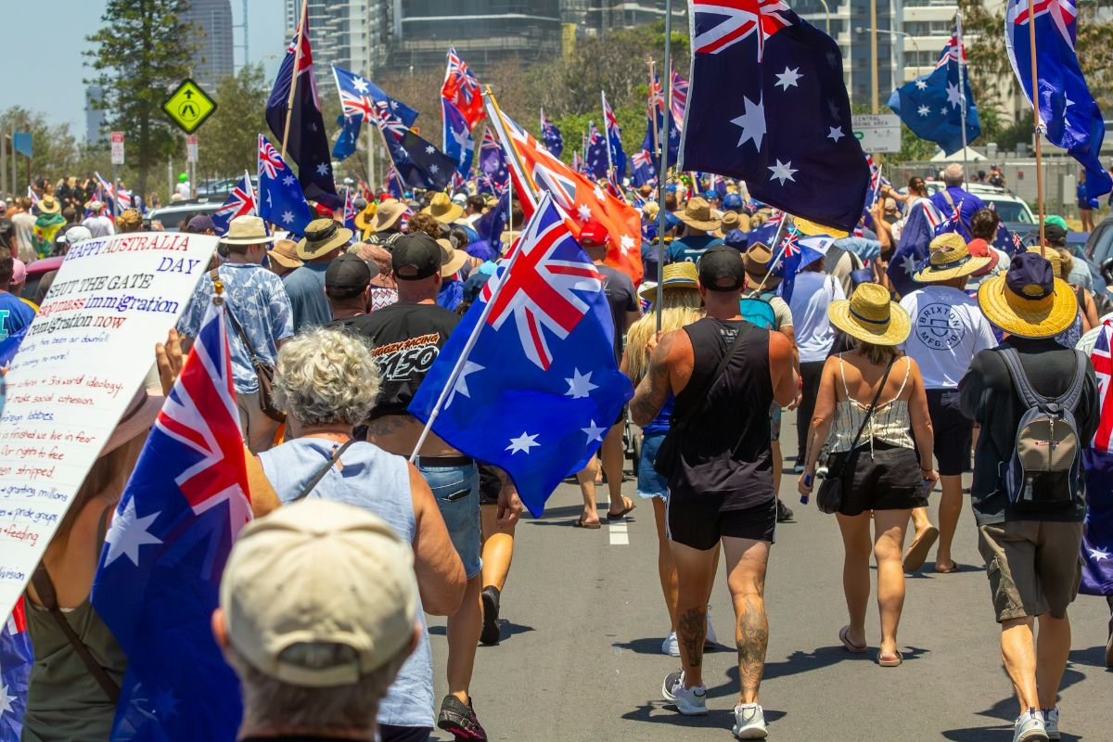
One Nation and the Global Populist Wave
Writing in The Conversation, Josh Sunman and Emily Foley argue that One Nation's surge in Australian polling is not an isolated domestic phenomenon but rather part of a "global anti-immigration push" in which radical right-wing politicians such as US President Donald Trump, Reform UK leader Nigel Farage and Italian Prime Minister Georgia Meloni are gaining traction at the ballot box and exerting increased influence over the global policy agenda. The piece places One Nation's popularity in Australia within a larger political dynamic whereby economic uncertainty and disenfranchisement fuel broader declining trust in political institutions.
The authors report that only 32% of Australians have trust in government, while just 30% report satisfaction with Australian democracy. The piece further identifies the collapse of the centre-right as a key structural enabler, noting that both the British Tories and the Australian Coalition have "left a vacuum of policy and leadership on the right." The March 2026 South Australian election, in which One Nation outpolled the Liberals statewide, ushers in a question that is echoed by these authors: is this a temporary protest vote or a far more serious and lasting realignment of the Australian right?
Image credit: DJ Paine via Unsplash

This column was selected by Federico Canas Velasco. Federico recently graduated from the University of Sydney with a Bachelor of Arts and Advanced Studies in International and Global Studies. He was previously the Latin American Fellow at Young Australians in International Affairs.

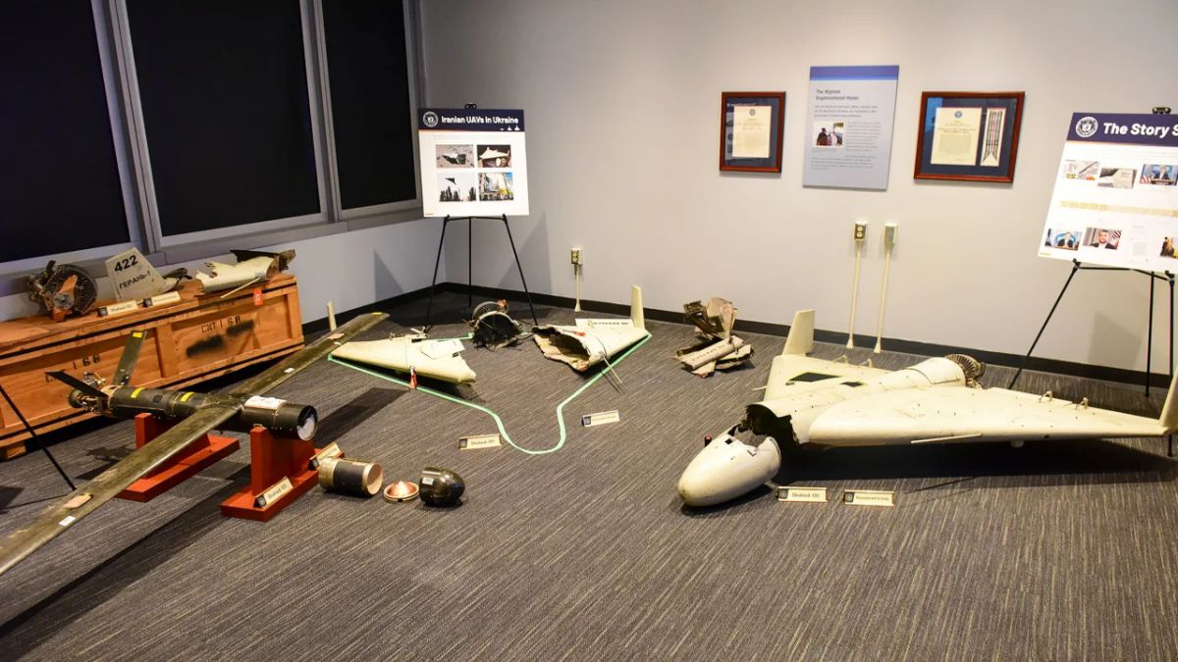
A New Era of Drone Warfare
Against the backdrop of the four years of war in Ukraine, and the current war on Iran, a new era in warfare has emerged. In an article for the Council on Foreign Relations, Michael C. Horowitz and Lauren Kahn describe this as a fundamental shift in modern conflict toward "precise mass" defined as the high-volume use of low-cost, autonomous, and highly accurate systems.
A central theme is the asymmetric cost ratio. Iranian-made Shahed-136 drones cost between US$20,000-$50,000 per unit, while US Patriot missile interceptors used to shoot them down cost roughly US$4 million apiece. This places the American defenders on the wrong side of the cost curve, rapidly depleting the country's air defense stockpiles. In response, the US has deployed the LUCAS (Low-Cost Unmanned Combat Attack System) in its attack on the Iranian regime, otherwise known as 'Operation Epic Fury'.
This article is important because it explains the differences between drones, such as one way attack (OWA), surveillance or loyal wingmen, rather than treating them as a single category. Ultimately, the authors argue that precise mass will become a regular feature of warfare, comparable to the historical introduction of tanks or machine guns.
Image credit: Shahed drones, U.S. Defense Intelligence Agency via Wikimedia Commons

This article was selected by Paolo Lini. Paolo is a masters student in War and Defence Studies at the Swedish Defence University and an exchange student at Macquarie University. He is a member of the Young European Federalists and writes for the European Student Think Tank.

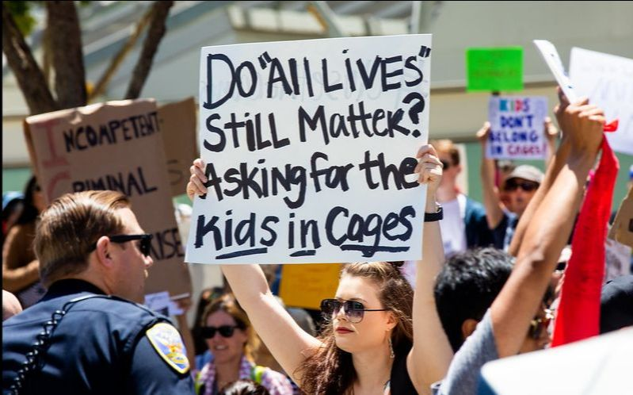

US Moving Pregnant Immigrant Girls to Texas to Avoid Providing Abortions
Writing in the Guardian on 1 March, Melody Schreiber reports that the US administration’s movement of pregnant unaccompanied immigrant children to a facility in Texas may be motivated by the administration's opposition to abortion. Located in Dilley, the South Texas Family Residential Center has detained children as young as 13 since July 2025, with half of them pregnant as a result of rape.
Schreiber assesses that the administration is consciously eroding detainees' right to reproductive healthcare by weaponising state-specific restrictions which make it difficult for a child to get an abortion. For girls who have fallen pregnant as a result of rape, there remains a disturbing lack of information about perpetrators' identities with many cases of sexual assault occurring either in their home country or in transit.
Amongst escalating concerns about human rights violations committed by ICE and reports of egregious abuse and unsanitary conditions within detention centres, the US continues to deny basic support to immigrants.
Image credit: Thomas Hawk via Flickr

This column was written by Kimmy Kwok. Kimmy is a third year student at the University of New South Wales studying a Bachelor of Law and Arts majoring in Politics and International Relations. She is currently President of UNSW's United Nations Society.

What else we're reading

- Louis Theroux on Netflix investigates the surge of toxic masculinity in his documentary "Inside the Manosphere", interviewing online stars on why they produce "red pill" content.
- Jason Vadnos of the Charles F. Kettering Foundation debunks "the myth of youth apathy" and argues that while Gen Z is sceptical of the current world order, they are not ignorant and remain actively engaged with political issues.
- Robert Pape joins The Diary of a CEO to unpack future scenarios for the war in Iran, focusing on how the United States is falling into an “escalation trap".
- In Pearls and Irritations, Miriam Farida predicts that Israel’s operations inside Lebanon against Hezbollah could lead to wider escalation and renewed Israeli occupation.
- ABC's Foreign Correspondent investigates the US seizure of Venezuela's oil industry, examining how Trump's high-stakes gamble to control 18% of the world's oil reserves risks deepening an already catastrophic humanitarian crisis.
- In The Conversation, Hazel Moir assesses the substantial free trade agreement concluded by Australia and the EU after eight years of complex negotiations.

Upcoming Events

Europe’s Unfinished Frontier: the Western Balkans between Brussels, Beijing, and Moscow
Join us on Tuesday 31 March at Glover Cottages for an address by Dr Nina Markovic Khaze, scholar at the Australian National University Centre for European Studies.
Dr Khaze will examine how Western Balkan states navigate these competing pressures while pursuing European integration. She will assess China's growing influence in the region, its implications for NATO and the European security architecture, and how the Balkans are evolving into a critical geopolitical pivot linking Europe, Eurasia and the Mediterranean. This discussion offers timely insights for policymakers, diplomats and security practitioners seeking to understand Europe's emerging strategic frontiers.
For further information please email
nswexec@internationalaffairs.org.au.

