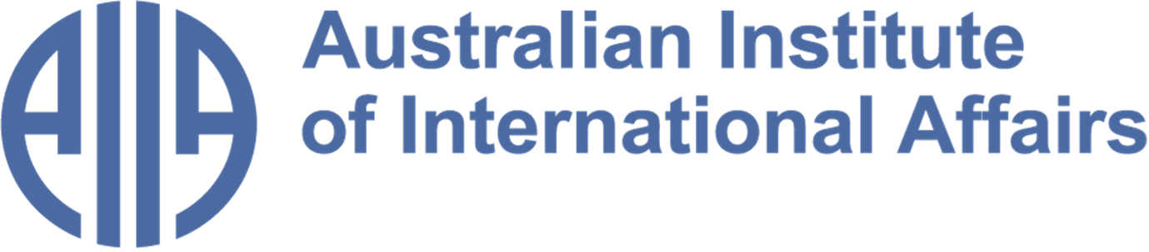

The Australian Institute of International Affairs New South Wales welcomes you to issue 113 of:



From the Councillors

​​Twice a month, some of our Councillors and interns share a selection of articles, analytical pieces, videos, and podcasts about what is happening in international affairs. This week, Jocelyn Chey reflects on the 2026 World Cup and the multicultural message Australia is bringing to the field, and Matthew Vasic assesses the Iran peace process.
Disclaimer: The views expressed below by councillors and interns are their own. The Australian Institute of International Affairs New South Wales does not take policy positions.

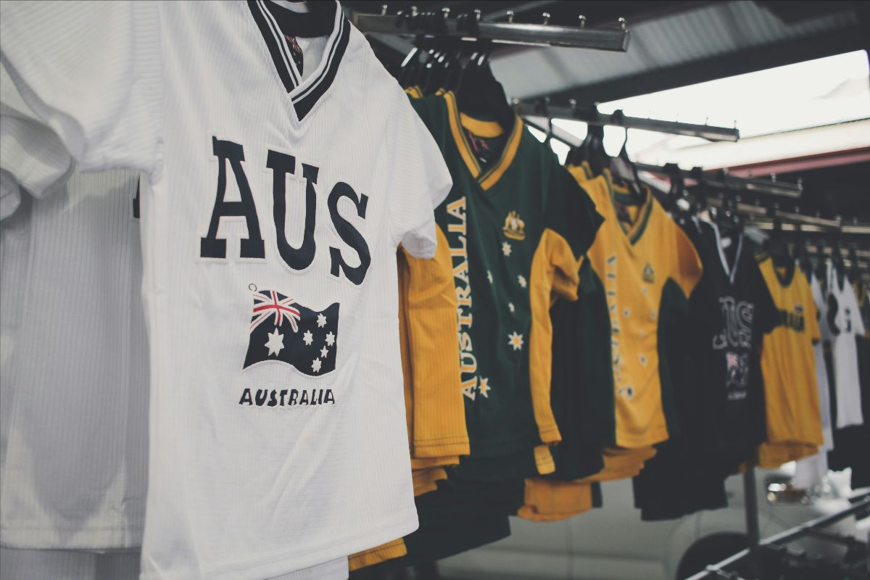

The World Cup and International Relations
The 2026 Football World Cup is obsessing audiences around the world including Australia. It is taking place against a backdrop of deep geopolitical tensions, not least the exclusionary policies of the United States, which is one of the North American hosts. Rights organisations have criticized these policies’ threats to foreign fans and immigrant communities.
It is reassuring to note that Australia does not condone US visa bans and border crackdowns. The Socceroos released a powerful video highlighting the diverse family backgrounds of the players. The message is that they, and we, should be proud of this country’s multicultural make-up, and that they, and we, can retain inherited traditions and cultures and still be proud to represent Australia on the world stage. As they say, “Our diversity is our strength”.
Image credit: RJ Baculo on Unsplash

This video was selected by Jocelyn Chey AM. Jocelyn is an Adjunct Professor at the Australia-China Relations Institute, University of Technology Sydney, Visiting Professor at the University of Sydney and an Adjunct Professor at the Australia-China Institute for Arts and Culture at Western Sydney University. She was previously a senior officer in the Department of Foreign Affairs and Trade. Jocelyn is a Fellow of the Australian Institute of International Affairs.

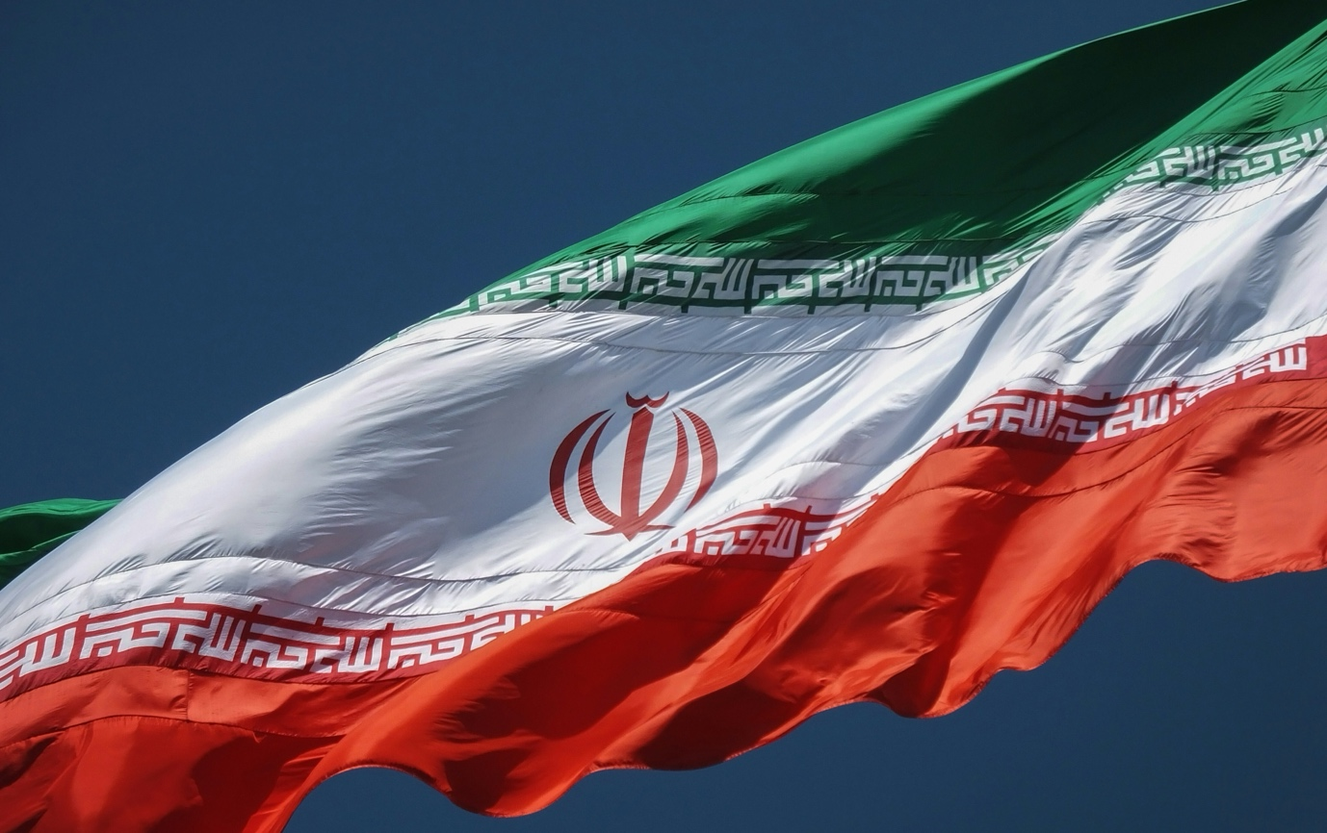
Is this what winning looks like?
The recent ceasefire extension agreement between Iran and the United States leaves Washington in a much weaker position than when the conflict began in February. At the outset of the war, both President Trump and Prime Minister Netanyahu identified regime change as their ultimate objective. In a prerecorded address following the assassination of Supreme Leader Khamenei, Trump called on Iranian protesters to “take over their government”, arguing that it was their final opportunity for generations to come.
Now, after months of conflict and Iran's continued blockade of the Strait of Hormuz, Washington has agreed to a new ceasefire agreement. The decision reportedly came after limited consultation with Israel and amid reports of an acrimonious phone call between President Trump and Prime Minister Netanyahu.
The BBC reports that the agreement paves the way for ending the Hormuz blockade and provides Tehran with more than US$300 billion in reconstruction and economic assistance from non-US donors, while Washington lifts sanctions in exchange for an Iranian moratorium on nuclear weapons production. Yet this concession appears to be of limited value. Tehran has long maintained that nuclear weapons are already prohibited under a fatwa issued by the late Supreme Leader Khamenei. Other longstanding American and Israeli concerns, including Iran's support for proxy networks and its ballistic missile arsenal, remain unaddressed.
Photo by sina drakhshani on Unsplash

This article is by Matthew Vasic. Matthew is a councillor and intern coordinator at AIIA NSW and a former intern, currently in his final year studying Law and International Studies at Western Sydney University. He has represented Australia at the ASEAN Youth and HPAIR conferences and has participated in the UN Economic and Social Council Youth Forum as an Australian delegate.

From the Interns

In addition to our Councillors' recommendations, we invite our interns to share with you what they have found insightful or interesting in the world of international affairs. This week, Federico Canas Velasco reflects on Venezuela's military crackdown on illegal gold mining and its ties to a US-backed foreign investment deal. Paolo Lini explores how Australia and Japan are quietly rewriting the rules of Indo-Pacific security cooperation, without a treaty in sight. Kimmy Kwok examines the coltan industry in the Democratic Republic of the Congo, and its connection to multinational corporations such as Amazon and Sony.
Disclaimer: The views expressed below by councillors and interns are their own. The Australian Institute of International Affairs New South Wales does not take policy positions.


Venezuela's Silent War
Writing in the Latin Times on 13 June, José Gutiérrez reports on a sweeping military operation across Venezuela’s gold-rich Bolívar state, where armed forces have moved into the Las Claritas and Kilometre 88 mines, displacing criminal syndicates that have controlled them for decades.
Gutiérrez emphasises that this is more than a security operation. For years, the Venezuelan state tolerated and even profited from the work of the criminal groups it is now expelling - with military figures reportedly taking cuts from illegal gold extraction activity. The deployment coincides with a US-brokered opening of Venezuela's mining sector to foreign capital, a $100 million gold shipment, and a new mining law that permits joint ventures and private capital in the sector.
As criminal groups retreat, they are reportedly destroying evidence of years of abuses and killings. There has been no official accountability from key figures, and human rights organisations are warning of extrajudicial risk to civilians. The state that enabled this violence is now clearing it away, as it courts foreign capital.
Image credit: Jingming Pan via Unsplash

This article was selected by Federico Canas Velasco. Federico recently graduated from the University of Sydney with a Bachelor of Arts and Advanced Studies in International and Global Studies. He was previously the Latin American Fellow at Young Australians in International Affairs.

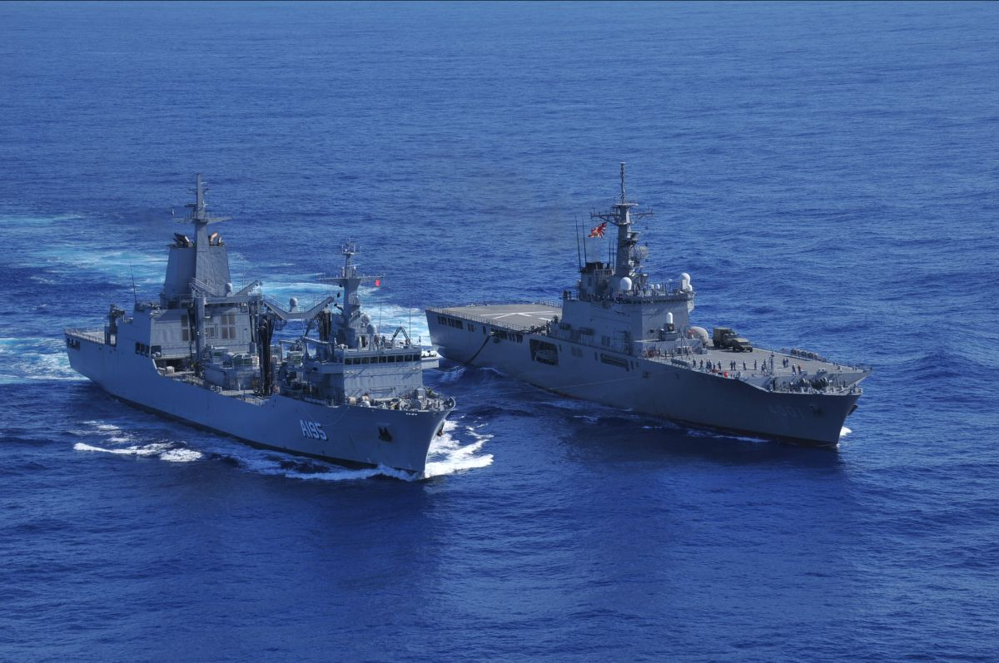
Without a Treaty: Australia and Japan in the Indo-Pacific
The Indo-Pacific has never been a region of neat alliance structures. Writing for the International Institute for Strategic Studies, Darshana M. Baruah argues that the defence partnership between Australia and Japan may offer precisely the kind of model the region now requires: operationally serious, strategically grounded, and built without a formal mutual defence treaty.
The architecture underpinning the relationship is robust. The 2022 Reciprocal Access Agreement - at the time Japan's only visiting-forces agreement outside its alliance with Washington - has generated over forty joint activities in a single year spanning air, maritime, land and cyber domains. Australia has since selected Japan's Mogami-class frigate as its next general-purpose vessel, and both countries are pursuing maritime autonomous systems under the AUKUS Pillar II framework. The December 2025 Framework for Strategic Defence Coordination formalises this alignment, committing both sides to strategic coordination at all levels and in all situations.
As Japan sits north, and Australia south, of the Taiwan Strait both countries offer unique vantage points on the region's most consequential flashpoint and can use their respective advantages to deepen interoperability. As Washington pushes its partners to shoulder more of the regional burden, Tokyo and Canberra are quietly demonstrating that deterrence cooperation does not require a treaty. It can be built, patiently, through shared threat perceptions and converging interests.
Image credit: JS Osumi (LST-4001) and HMAS Supply (A195), Japan Maritime Self-Defense Force via Wikimedia Commons

This article was selected by Paolo Lini. Paolo is a Masters student in War and Defence Studies at the Swedish Defence University and an exchange student at Macquarie University. He is a member of the Young European Federalists and writes for the European Student Think Tank.

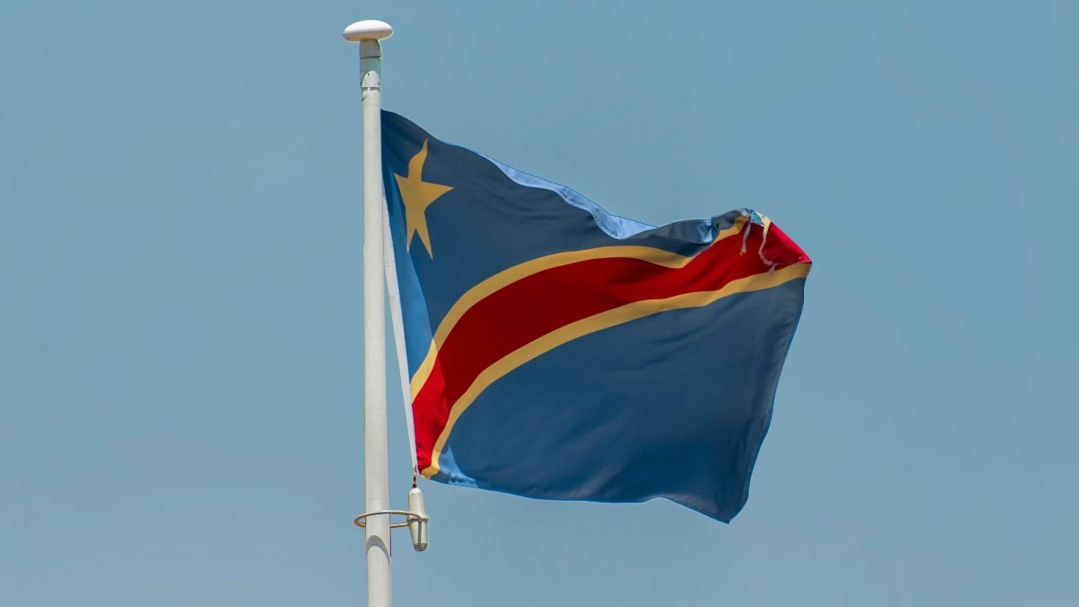

Corporate Culpability: The Issue of Coltan in the Democratic Republic of the Congo
Mark Townsend, writing for The Guardian, reports on a year-long investigation by Global Witness into coltan supply chains in the DRC. Coltan is an essential mineral used in downsizing portable electronics. Fifteen percent of the world's supply comes from Rubaya, a vast mining site in DRC's North Kivu province.
Townsend considers that leading global brands including Amazon and Sony are "likely" to have sourced minerals from the region, which has been controlled by the M23 militia group since 2024. Backed by up to 7,000 Rwandan troops, M23 has seized vast tracts of territory within the region and displaced many of its inhabitants and committed atrocities such as large-scale physical and sexual assault.
Unveiling new knowledge on the operation of coltan supply chains, Townsend emphasises the need to investigate the complicity of Rwandan officials and corporations, and asks whether international traceability systems that identify conflict-free supply chains have adequately accounted for the role of coltan as a conflict mineral.
Image credit: Aboodi Vesakaran via Unsplash

This column was written by Kimmy Kwok. Kimmy is a third year student at the University of New South Wales studying a Bachelor of Law and Arts majoring in Politics and International Relations. She is currently President of UNSW's United Nations Society.

What else we're reading

- In El País, Juan Diego Quesada examines how former Spanish Prime Minister Zapatero spent a decade as an informal mediator in Venezuela, cultivating ties with the Chavista government while consistently avoiding criticism of its repression and electoral fraud.
- Criticising the lack of Greek representation in Nolan's upcoming blockbuster The Odyssey, Chris Cotonou for The Guardian explores Hollywood's sense of entitlement to Hellenic stories and its implications on broader themes in media and literature.
- Writing in The Conversation, Caitlin Byrne argues that the 2026 World Cup represents a missed soft power opportunity for the United States, reflecting the exclusivity and xenophobia of Trump's America rather than goodwill and openness.
- Emese Ilyés reports in Common Dreams on the historical Knicks win and what it teaches us about the discipline of "persisting" under the Trump administration.
- Michelle Grattan in The Conversation notes that Pauline Hanson, whose One Nation party has been rising in the polls, was critical in her 17 June National Press Club address of multiculturalism and immigration by non-English speakers.
- In Foreign Policy (US) Joshua Leifer conjectures that the joint US-Israeli war on Iran may cloak – or have precipitated – a growing divergence between the US and Israeli leaderships on Middle East strategic policy.

Upcoming Events

Conventional Maritime Deterrence: The Operational Foundations of Influence at Sea
Join us on Tuesday 23 June at Glover Cottages for the launch of Associate Professor Adam Lockyer's latest book: Conventional Maritime Deterrence.
He updates our understanding of how deterrence at sea differs from its terrestrial counterpart. He examines four types of maritime deterrence strategies: offensive sea control, defensive sea control, offensive sea denial and defensive sea denial. His ultimate finding is that the credibility of conventional maritime deterrence rests on what a naval power can be seen to do rather than what it can do. This important book will provide the public, policymakers, naval officers, and scholars of international relations with insight into both current and future maritime deterrence.
For further information please email
nswexec@internationalaffairs.org.au.

