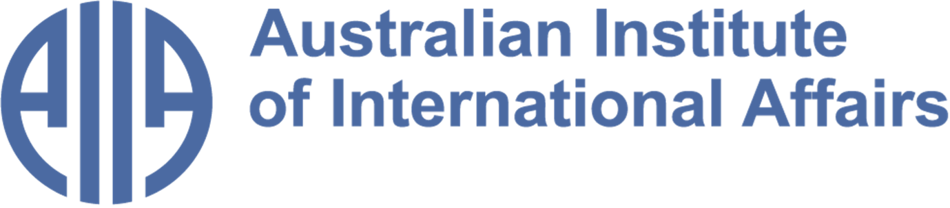

The Australian Institute of International Affairs New South Wales welcomes you to issue 114 of:

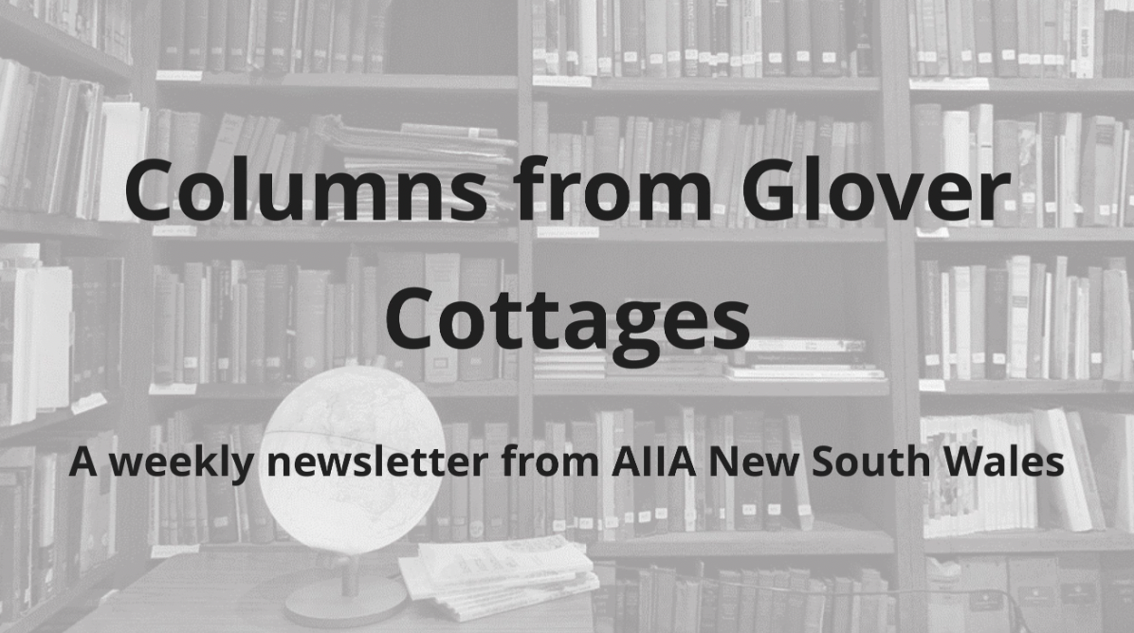

From the Councillors

​​Twice a month, some of our Councillors and interns share a selection of articles, analytical pieces, videos, and podcasts about what is happening in international affairs. This week, Jocelyn Chey discusses the progress made in the AUKUS Public Inquiry and Ian Lincoln reflects on the Russia-Ukraine war, five years in.
Disclaimer: The views expressed below by councillors and interns are their own. The Australian Institute of International Affairs New South Wales does not take policy positions.

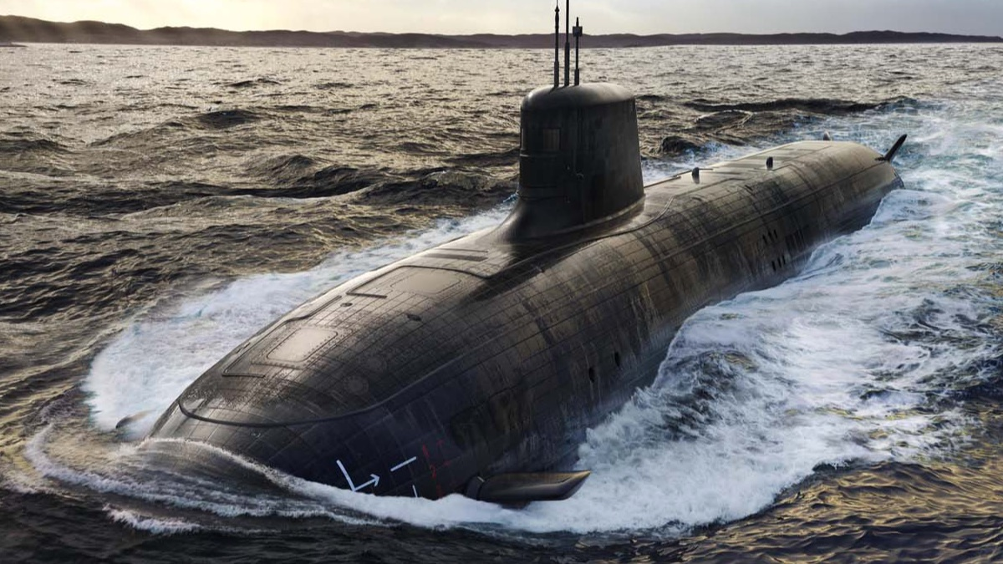

AUKUS Inquiry update
The independent AUKUS Public Inquiry held a Hearing in Sydney on 10 August. Speakers included AIIA NSW Councillor Jocelyn Chey, whose submission will be published on the Inquiry website. Public hearings are continuing, and submissions are still being received, with a final report scheduled for publication by October 30, 2026. Commissioners are examining the $368 billion price tag, transparency and parliamentary oversight, nuclear waste management, and national sovereignty.
To date, over 500 submissions have been received, revealing an overwhelming community and expert consensus critical of the $368 billion defence pact. Submissions from high-profile political figures, including former ministers Gareth Evans, Christopher Pyne, and Linda Reynolds, highlight anxiety regarding the policy’s execution and strategic value. Civil society organisations have focused heavily on nuclear non-proliferation risks, warning that military reactors fueled by highly enriched uranium exploit dangerous legal safeguards loopholes.
Overall, concerns include: that Australia is being locked into the US military structure at the expense of its independence; that the dangers of domestic storage and long-term environmental risks of high-level radioactive waste have not been considered; that the cost is diverting billions from housing, health, and climate action; and that the deal makes Australia a nuclear target and damages regional relationship dynamics. Very few submissions processed to date actively support the current policy framework.
Image credit: BAE Systems, Artist rendering of possible design for SSN-AUKUS submarines, via Wikimedia Commons

This update was provided by Jocelyn Chey AM. Jocelyn is an Adjunct Professor at the Australia-China Relations Institute, University of Technology Sydney, Visiting Professor at the University of Sydney and an Adjunct Professor at the Australia-China Institute for Arts and Culture at Western Sydney University. She was previously a senior officer in the Department of Foreign Affairs and Trade. Jocelyn is a Fellow of the Australian Institute of International Affairs.

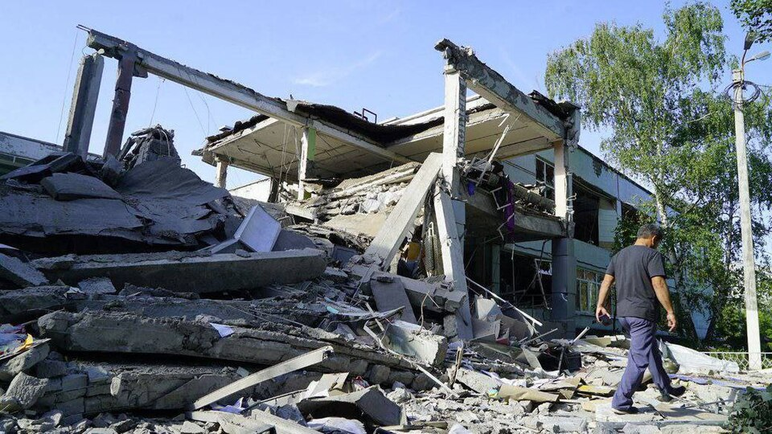
Is the tide turning in the Russia-Ukraine war?
With the Ukraine-Russia war now in its fifth year, most international reporting focuses on Ukraine’s successes - with US and other western support - in attacks on Russian infrastructure, shipping and population centres. These reports detect signs of increasing economic difficulties for Russia in continuing its war effort and predict challenges to Putin’s supremacy.
But Owen Matthews in The Spectator of 5 August gives a more sombre analysis. He observes that Kiev continues to suffer Russian ballistic missile attacks with mounting casualties and infrastructure destruction. Due to the demands of the US-Israeli war on Iran, there is little prospect of additional US supplies of the PAC-3 Patriot interceptors which have proved effective against Russian missiles. Russian missile attacks are increasing. Ukraine's vital port at Odessa has effectively been put out of action, and alternative routes for its grain exports have limited capacity.
Russia remains able to continue its destruction of Ukraine's energy, water, petrol, and heating infrastructures. The coming winter will see unrelenting Russian ballistic attacks, with damaging consequences for Ukraine's war effort and for President Zelensky's support. Despite Ukrainian attacks, Russia's war economy is far from crippled. The defensive weaponry provided to Ukraine by Western powers has not turned the tide.
Image credit: 17th school of Kharkiv after Russian shelling (02).jpg from Wikimedia Commons

This article was selected by Ian Lincoln, President of AIIA NSW since 2017. Ian was in the Department of Foreign Affairs for 33 years including postings in Asia, Africa, Europe and the Pacific. He was later an appellate member of the Refugee Review Tribunal and has worked in a number of community organisations.

From the Interns

In addition to our Councillors' recommendations, we invite our interns to share with you what they have found insightful or interesting in the world of international affairs. This week, Jack Bettar examines the diplomatic tensions in North Africa, Rebecca Wallwork considers the Flamingo Revolution in Albania, and Mia Conway looks to understand the role of social media in the 2025 Nepalese Gen Z protests.
Disclaimer: The views expressed below by councillors and interns are their own. The Australian Institute of International Affairs New South Wales does not take policy positions.

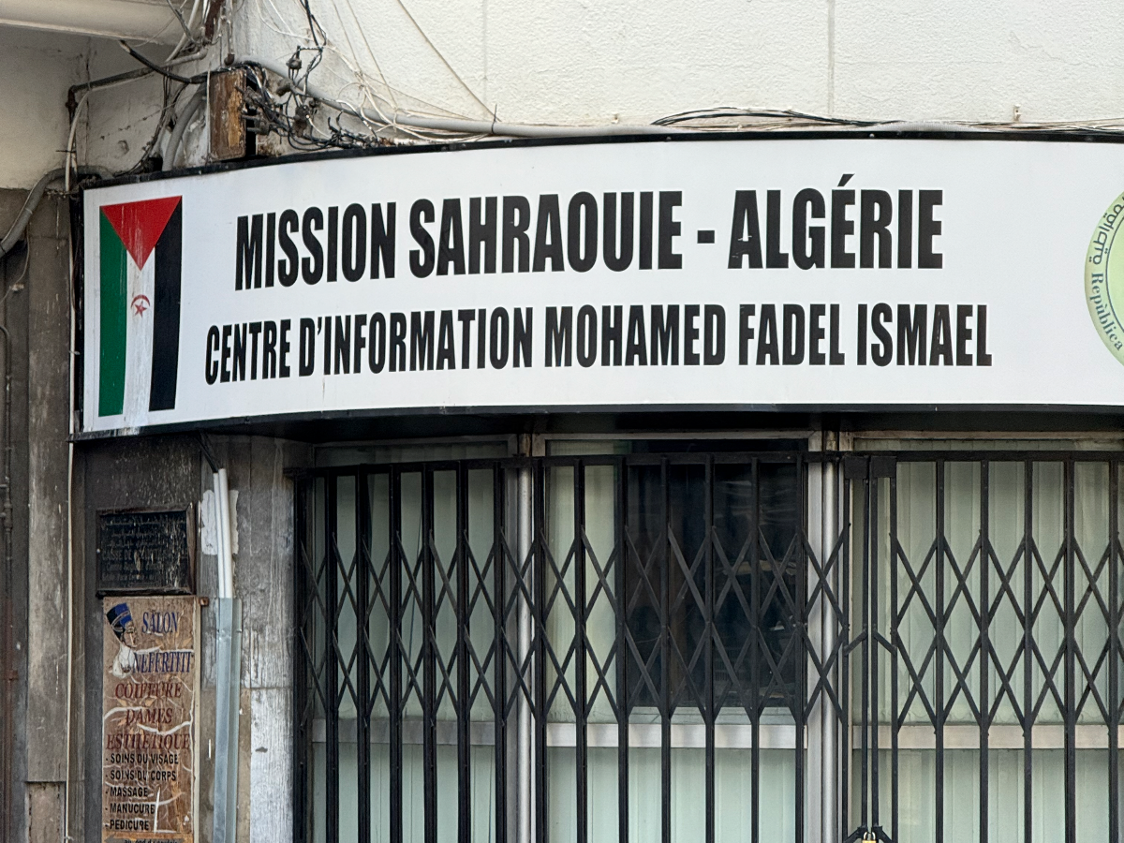
Morocco and Algeria: old rivals with new tensions?
The diplomatic rivalry between Algeria and Morocco has shaped North African geopolitics and foreign affairs for several decades. Recently, both countries made headlines again in relation to Spain’s influence in the region, as thousands of migrants from Morocco crossed into the Spanish-held island of Ceuta, a colonial-era possession just north of Morocco's Mediterranean coast. The event coincided with Spanish Prime Minister Pedro Sánchez’s visit to Algiers, prompting speculation that Morocco may have deliberately allowed the influx of migrants as a bargaining chip. Writing for Deutsche Welle, Kersten Knipp revisits the origins of the deep-seated rift between the two Maghrebi nations over the Western Sahara, from which Spain withdrew in 1975. Morocco maintains historical claims to the territory, while Algeria opposes Moroccan territorial expansion and supports Sahrawi self-determination and the independentist Polisario Front.
Despite a UN-brokered ceasefire in 1991, a referendum allowing the Sahrawi people to determine the territory’s future has never taken place. Knipp argues that the dispute has evolved beyond the question of Western Sahara itself, becoming a competition for regional influence, military power and international partnerships. This is evident in Morocco’s normalisation of relations with Israel in 2020, which Algeria views as a potential security threat capable of shifting the regional balance of power to its detriment. As Knipp reports, the rivalry has consequently developed into a broader security dilemma, with each country interpreting the other’s actions as a threat, while both remain strategically important to Europe in different ways.
Image credit: Jack Bettar - the West Saharan diplomatic mission photographed in Algiers, Algeria (January 2026).

This column was written by Jack Bettar. Jack is a Bachelor of Laws and Bachelor of Communications (Political and Social Sciences) student at the University of Technology Sydney. He has undertaken research and fieldwork in Egypt as part of a multidisciplinary expedition and has contributed to publications on the social and cultural history of the region.

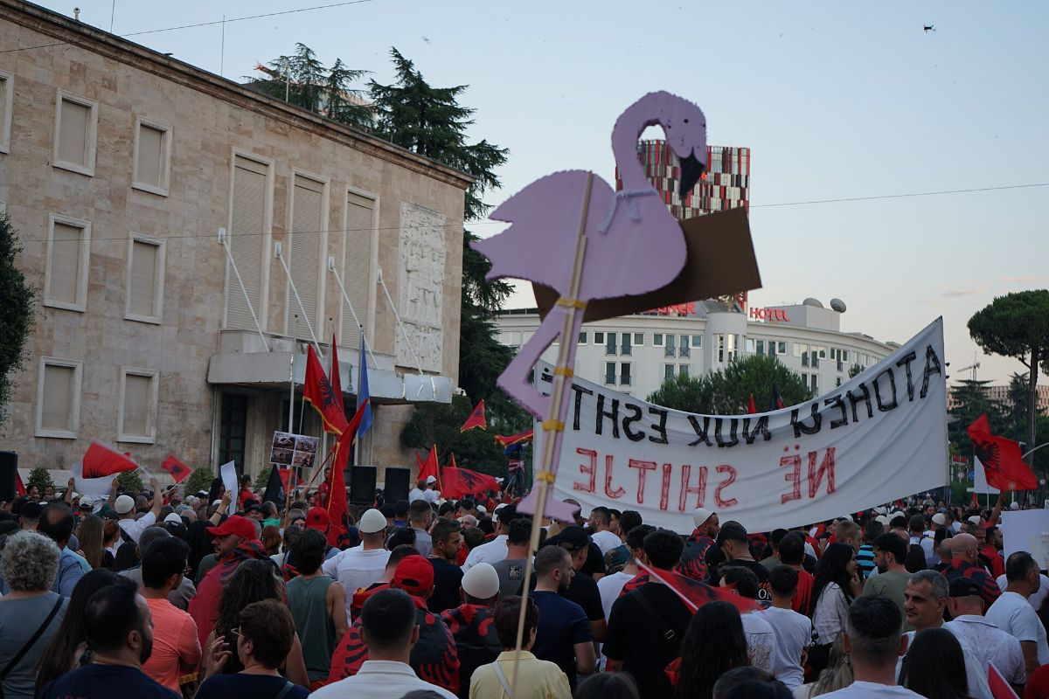
Oligarchy and environmentalism in Albania
In a recent episode of his ABC podcast If You’re Listening, Matt Bevan examines the ‘Flamingo Revolution’. This ongoing Albanian anti-government protest movement began in response to the government recently cutting red tape to enable a resort development project in the protected Norta Lagoon reserve. This environmentally-disruptive development has since drawn international attention, not least because the project is backed by Donald Trump’s son-in-law Jared Kushner.
The Flamingo symbolises the extensive birdlife supported by the Lagoon, home also to other endangered species like the Loggerhead Sea Turtle. As distressing as the environmental risks are, Bevan highlights that the real frustration for many Albanians is the willingness of their government to take regulatory shortcuts. Following the end of communism in the 1990s, over half of Albania's most vulnerable people with limited financial literacy were taken advantage of by unregulated Ponzi schemes. This led to poverty and widespread protests, and according to Bevan, left the nation with a strong distrust of the Government and get-rich-quick schemes.
Overall, Bevan offers a compelling analysis of the risks posed by a development model that lacks transparency and adequate public interest safeguards. It will be interesting to see how the Government, in a country accustomed to long years of totalitarian rule, responds to the evolving pressure from civil society.
Image credit: Albinfo, Flamingo Revolution – protests against the government in Tirana on June 21 2026, via Wikimedia Commons

This column was written by Rebecca Wallwork. Rebecca is a fourth-year Bachelor of Arts/Laws student at the University of Sydney, with a major in Economics. She completed a six-month exchange to Peking University in 2025 and is a current Westpac Australia-Asia Fellow.

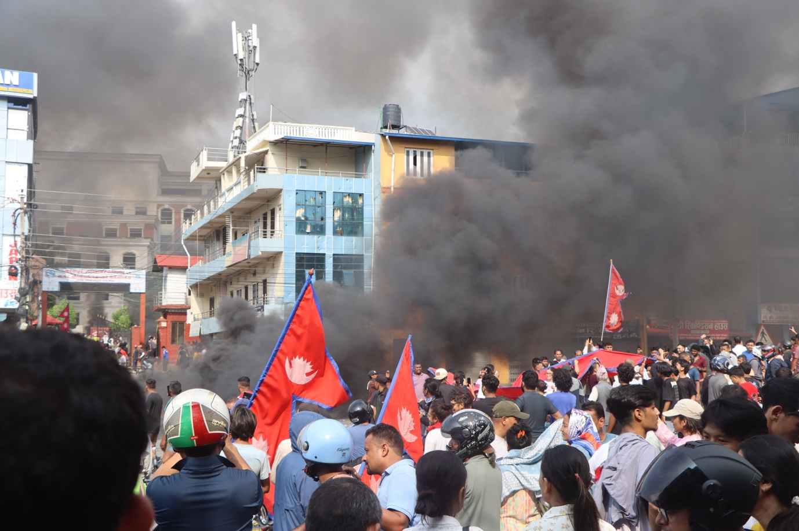

Algorithms do not moderate themselves
Nepal's Gen Z protests expose the volatile intersection of social media, highly reactive electoral content and limited moderation. Within days, a campaign that began on Reddit and Discord engulfed the parliament, Supreme Court and key ministries in an arson spree, forcing the resignation of Prime Minister K.P. Sharma Oli.
By opening up participation for groups typically absent from political life, digital platforms often have a democratising effect - but they can also lead to fragmentation and confrontation. Algorithms feed us personalised content harvested from social interactions, and in maximising engagement for advertising revenue, they feed off increased polarisation, misinformation and political volatility.
Social media is now a sphere of political engagement, and Darío García de Viedma of the Elcano Royal Institute argues it must be moderated as one. Top-down content moderation fails to address the structural drivers of harmful content, often overlooking marginalised communities while concentrating editorial authority among unelected and unaccountable platform operators.
García de Viedma proposes consensus-oriented platforms such as Prosocial Media, which rank content based on cross-community agreement and ensure minority perspectives are represented. The Nepali case illustrates the value of this approach: rather than amplifying division, it could have highlighted areas of genuine consensus among protesters.
Image credit: हिमाल सुवेदी , 2025 Nepalese Gen Z protesters infront of Bharatpur on September 2025, via Wikimedia Commons

This column was written by Mia Conway. Mia is a fourth-year student completing a Bachelor of Social Sciences and a Diploma of Languages at the University of New South Wales. She currently researches for Protocol, a youth-led policy lab, in their technology and democracy team.

What else we're reading

- Writing in The Conversation, Chad Hewitt, Gregory Ruiz, Ian Davidson and Mario Tamburri examine the overlooked risks of ecological damage emerging from the hulls of ships laid up in the Persian/Arabian Gulf, when the Strait of Hormuz reopens.
- Arwa Mahdawi in The Guardian criticises new Centres for Disease Control and Prevention (CDC) director Dr Erica Schwartz's recent comments on abortion, as politicisation of US public health institutions increases.
- In The Guardian, Agence France-Presse reports that Spanish hotel group Meliá will cease all operations in Cuba, citing US sanctions under Donald Trump that have made conditions “impossible".
- Michael Bustamante and Ricardo Zuniga in Foreign Affairs weigh up how far Donald Trump would go to have "the honor of taking Cuba", reading his interventions in Venezuela and Iran as warning signs.
- On the Lever Time podcast, Natalie Bettendorf speaks with David Dayen, executive editor of The American Prospect, about Abdul El-Sayed’s landmark win in Michigan, the must-watch primary races ahead, and the bizarre new landscape of political campaigns.
- Associated Press reports that the Syrian Foreign Ministry has stated that Russia will relinquish control of the Hmeimem air base and the commercial berth at Tartus port, with the sites becoming joint Russian-Syrian training centres under a new agreement.

Upcoming Events

A visitor’s view: are Palestinians in the West Bank subject to apartheid?
Join us to hear from writer Jeremy Webb on Tuesday 18 August. In this presentation, Webb describes his impressions from a recent 10 day tour of the Palestinian West Bank. His focus is on how the Israeli government and Israeli settlers interact socially, economically and politically with Palestinian residents. He asks whether this amounts to the imposition of apartheid as defined by international organisations.
We welcome participants in-person at the Glover Cottages, tickets to be pre-paid . Once the limit for in-person attendees is reached, tickets will no longer be sold on the website or at the door. Refreshments will be served from 6pm at Glover Cottages. The event will start at 6.30pm AEST (Sydney, Canberra, Melbourne time), Tuesday August 18.

