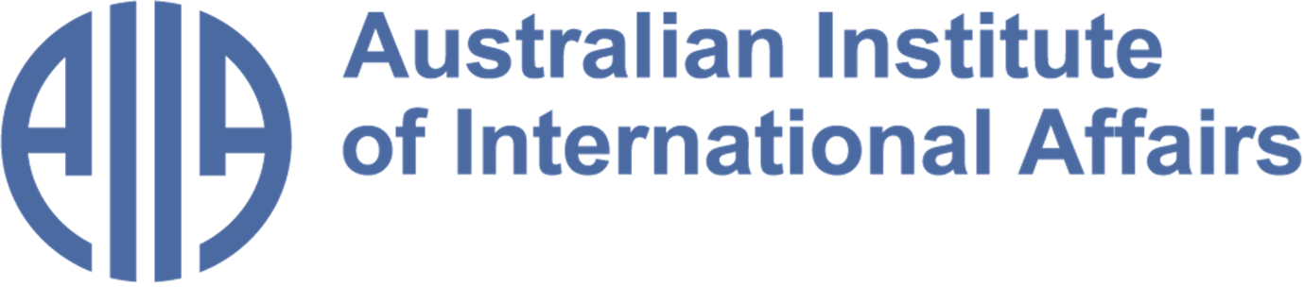

The Australian Institute of International Affairs New South Wales welcomes you to issue 110 of:



From the Councillors

​​Twice a month, some of our Councillors and interns share a selection of articles, analytical pieces, videos, and podcasts about what is happening in international affairs. This week Jocelyn Chey explores the interplay between culture and economics that has the power to shape development and international relations, Chris Skinner discusses the uncertainty of the international order in light of US foreign policy and Matthew Vasic recalls the parallels between the Iran-Iraq War of the 1980s and ongoing calls for revolution in present-day Iran.
Disclaimer: The views expressed below by councillors and interns are their own. The Australian Institute of International Affairs New South Wales does not take policy positions.

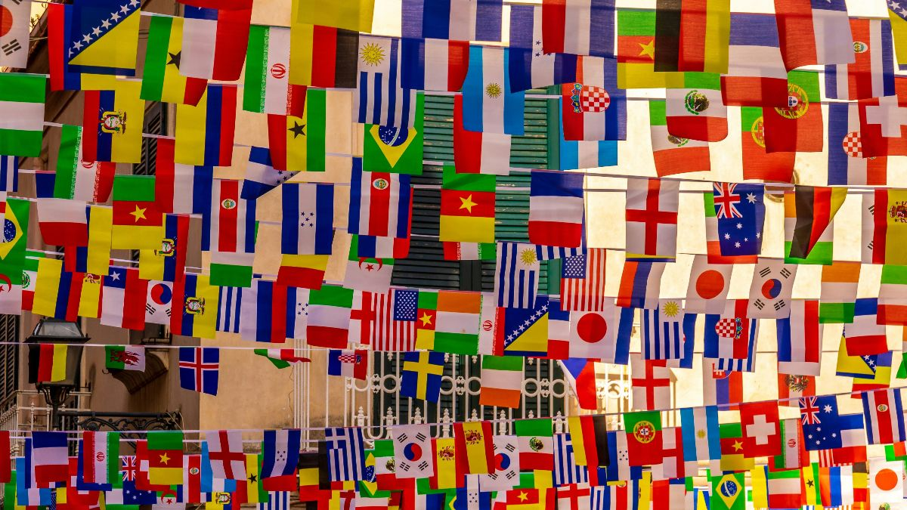

Cultures Merging

Does “culture” matter? This question has been on my mind for some time, so I pulled down from my bookshelf Cultures Merging by former Melbourne Business School Professor Eric Jones. Originally published by Princeton University Press in 2006, I found it has stood the test of time. It is very readable and thought-provoking, but leaves me with several knotty issues that need more research.
Eric Jones was an economist with a contrarian streak. He believed that culture and economics are intimately connected, that culture is fluid, mostly evolving slowly and sometimes changing rapidly and that it helps shape economic development and international relations. According to Jones, migrant communities like Australia’s have shown remarkable ability to adapt and change. In other parts of the world some religions live stubbornly in the past. To me the moral is that competition between cultures and within cultures is needed to stir continuing change and progress.
Remember this when people talk about the need to uphold traditional values and oppose immigration.
Image credit: Image credit: Global Flags, Nick Fewings via Unsplash

This book was selected by Jocelyn Chey AM. Jocelyn is an Adjunct Professor at the Australia-China Relations Institute, University of Technology Sydney, Visiting Professor at the University of Sydney and an Adjunct Professor at the Australia-China Institute for Arts and Culture at Western Sydney University. She was previously a senior officer in the Department of Foreign Affairs and Trade. Jocelyn is a Fellow of the Australian Institute of International Affairs.

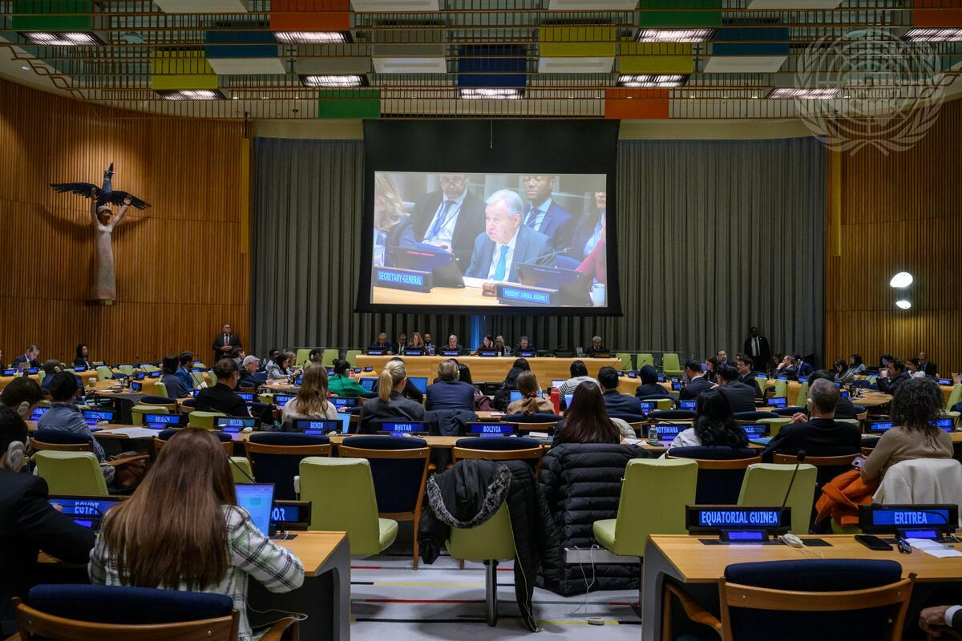

US Foreign Policy in a Multipolar World

Stacie E. Goddard's review of Emma Ashford's essay First Among Equals: US Foreign Policy in a Multipolar World in Foreign Affairs this month includes the following excerpts:
A "concept of a national interest incorporates the idea that a country’s aims abroad must be both collective and contested. A foreign policy based on the national interest must appeal to different interests within a society; its aims and means have to make sense to the public as a call for collective action."
The review concludes that the work is "a clear-eyed assessment of contemporary global power dynamics, a well-reasoned argument in favor of international partnerships, and a sober warning about the consequences of provoking catastrophic conflict. It is an eminently rational foreign policy blueprint. But her too-brief treatment of realism’s public relations problem falls into a familiar and unnecessary trap. For realist internationalism to prevail as a grand strategy, its adherents need to develop a moral narrative that can win hearts, not only minds.'
For me this provided a profound insight into the dynamics and shortcomings of US foreign policy in the past several decades and is helpful in conceiving how the current chaotic world of international relationships may develop.
Image credit: The United Nations General Assembly, Loey Felipe via UN Media

This article was selected by Chris Skinner. Chris served thirty years in the Royal Australian Navy in warships that participated in the South East Asian Treaty Organisation, the Vietnam War and surveillance of the North-West Indian Ocean. He joined the AIIA NSW Council in 2019.

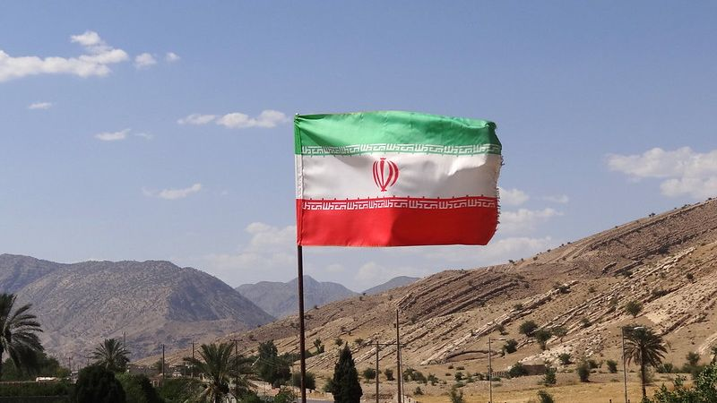

Waiting for Revolution in Iran? So is Saddam Hussein
In August 1978, as protests against the Shah paralysed Iran, the CIA issued an infamous prediction: “Iran is not in a revolutionary or even a pre-revolutionary situation.” But this is not 1978. Determined not to suffer the Shah’s fate, the Ayatollahs now command the world’s third-largest paramilitary force - the Islamic Revolutionary Guard Corps (IRGC) - whose primary role, according to former IRGC chief Mohammad Ali Jafari, is not to defend the country from external threats, but to suppress internal dissent.
Unlike the regular army (Artesh), the IRGC reports exclusively to Iran’s Supreme Leader, Ayatollah Khamenei, and serves as the regime’s Praetorian Guard. It possesses a larger armed force and a more extensive military stockpile than the Artesh, with which it competes in both domestic and foreign policy arenas. This is why the US and Israel have disproportionately assassinated IRGC commanders - rather than those of the Artesh - in recent airstrikes: to foment unrest. In an article for the Washington Institute, Saeid Golkar argues that the IRGC and intelligence services (MOIS) have been ruthlessly effective in infiltrating and dismantling protest movements.
In a cruel irony, the US and Israel now find themselves in a similar position to Saddam Hussein, who believed he could trigger a counter-revolution in Iran following a devastating surprise air attack in September 1980. Instead, most Iranians rallied to defend their country, and what Saddam had assumed would be a months-long war dragged on for eight bloody years.
Image credit: Iranian Flag, Adam Jones via Flickr, CC BY 2.0

This article was selected by Matthew Vasic. Matthew is a councillor and intern coordinator at AIIA NSW and a former intern, currently in his final year studying Law and International Studies at Western Sydney University. He has represented Australia at the ASEAN Youth and HPAIR conferences and has participated in the UN Economic and Social Council Youth Forum as an Australian delegate.

From the Interns

In addition to our Councillors' recommendations, we invite our interns to share with you what they have found insightful or interesting in the world of international affairs. This week, Clodia reflects on the formation of Australia’s modern foreign policy. Mehnaaz reviews the questions surrounding Trump’s war on Iran and Australia’s support and involvement. Jemma shares a suggestion for deeper Asian economic integration in response to Trump’s tariffs.
Disclaimer: The views expressed below by councillors and interns are their own. The Australian Institute of International Affairs New South Wales does not take policy positions.

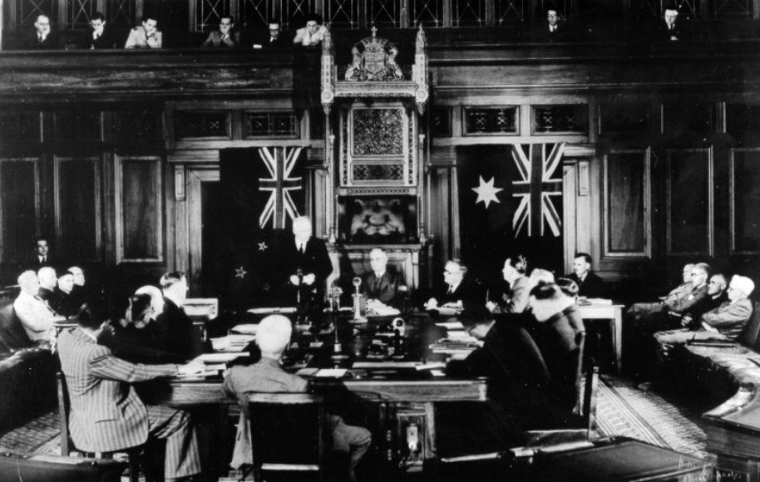
New friends in an era of Abandonment
'Fear of Abandonment: Australia in the World Since 1942' by Allan Gyngell offers a compelling narrative on the formation of Australia’s modern foreign policy. Drawing on decades of experience as a diplomat, and as a policy adviser, Gyngell presents the history of how Australia has navigated an uncertain international environment since the signing of the Statute of Westminster in 1942.
At the centre of the book is a simple but powerful idea: Australian foreign policy has been shaped by a persistent “fear of abandonment.” An abandonment first by Britain during the Pacific War and later, and arguably now, by the United States. Navigating the reader through key moments in Australia’s diplomatic history - from the creation of the ANZUS alliance and Cold War conflicts in Asia, and more recent debates about China and the Indo-Pacific, Gyngell reminds audiences that foreign policy is not only shaped by geography but by strategic power play.
Whilst, I may be a few years late in reading the ‘Fear of Abandonment’, Gyngell’s reflections on Australia’s place in the international system remain strikingly relevant. The book serves as both a historical guide and a reminder that the challenges of navigating asymmetric alliances are far from over.
Image credit: Statute of Westminster via John Curtin, Prime Ministerial Library

This column was written by Clodia Stanislaus. Clodia is a final-year Bachelor of Politics, Philosophy and Economics student at the University of New South Wales majoring in Politics and International Relations. She is a Youth Committee Member of the Global Institute of Women's Leadership at ANU.

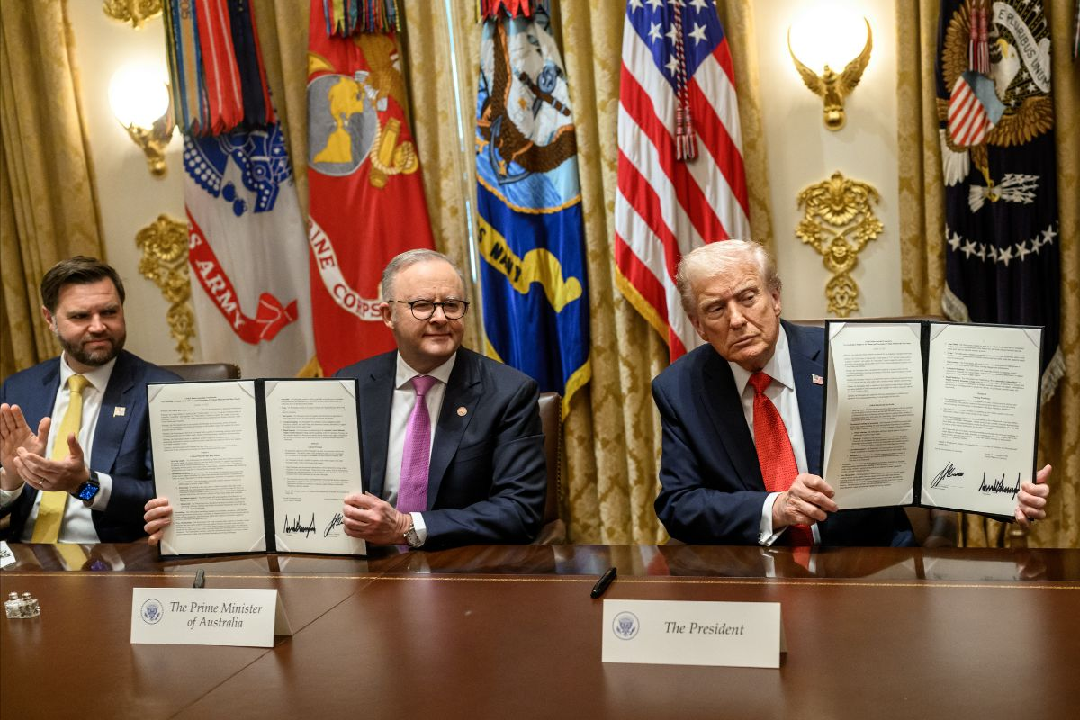

What is Australia’s role in Trump’s war on Iran?
After the death of approximately 168 Iranian schoolgirls in Minab, described by human rights organisations as a grave violation of international law, Australia’s support for the firing of US-Israeli missiles is being interrogated. Journalists Osman Faruqi and Scott Mitchell scrutinise the war in Iran on their Lamestream podcast, speaking on an episode titled ‘Assassinations, Retaliation, and How Australia’s Support Could Backfire’.
The episode begins by reminding listeners that the US-Israeli strikes began surprisingly amidst ongoing negotiations regarding defence and national security with Iran in Geneva, and followed with unprecedented Iranian strikes on US bases in neighbouring nations. They question Australia’s role as the first country to support Trump’s actions, particularly given the relative reluctance of other Western nations (such as the United Kingdom, France, and Germany) to provide support. This strong support is also notable given the Trump’s administration’s unclear and variable motivations behind starting the war; Mitchell reports that when asked for explanations, Trump’s answers range from pre-emptive strikes, to nuclear deterrence, to the freedom of the Iranian people. The hosts essentially spend the episode asking: what does it mean for Australia to support a war waged by a very unpredictable ‘ally’?
Given increasing casualties and the likelihood of sustained attacks from both US-Israel and Iran, Faruqi and Mitchell clearly explain how it is more important than ever to analyse Australia’s role in this war.
Image credit: The White House, Daniel Torok via Flickr

This podcast episode was selected by Mehnaaz Hossain. Mehnaaz is an Honours student in Government and International Relations at the University of Sydney. She was previously an editor for the University of Sydney’s student newspaper Honi Soit.

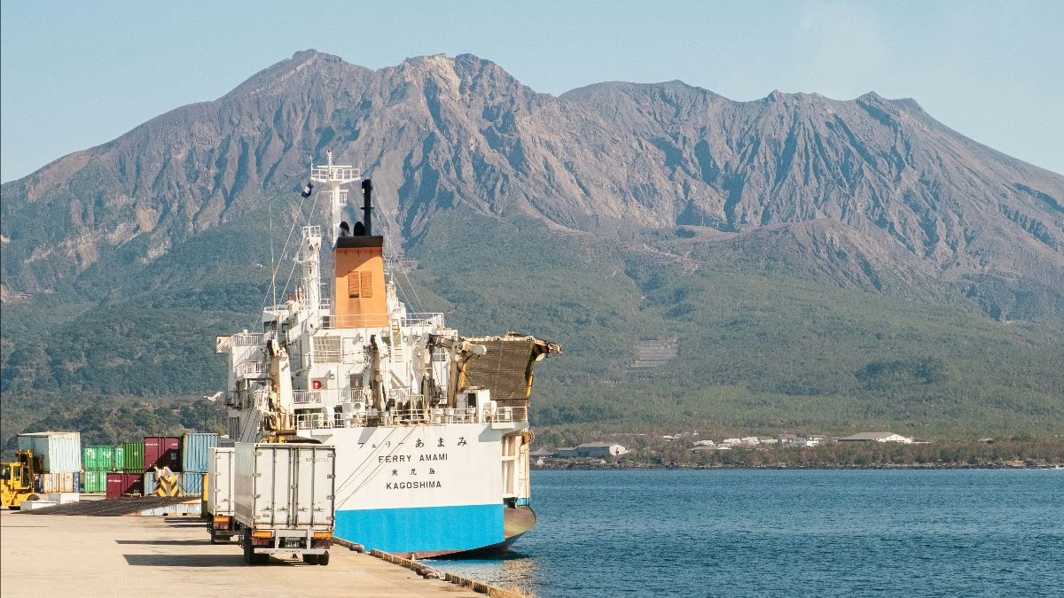

Asia Cannot Just Wait for Trump to Chicken Out
As the aftershocks of US President Donald Trump’s sweeping ‘Liberation Day’ tariffs exact a lingering impact, Professor Alan Winters’ calls for a renewed Asian consensus on multilateralism. Writing against the ‘TACO’ mindset or assumption that “Trump always chickens out”, Winters argues for Asian nations to undergo deeper integration and pursue a proactive, self-reliant trade strategy to offset US uncertainty.
While Trump’s tariff agenda has been consistently marred with frequent reversals, sweeping announcements and failures to follow through, US tariffs have effectively remained at a historical high. Many countries have already sought through purchase commitments and regulatory import preferences to avoid harsher retribution, yet this pattern is unsustainable. Nations throughout Asia that concede to American demands have only signified their vulnerability to coercion; rendering future negotiations politically challenging.
In response, Winters champions a growing consensus towards multipolarity and the alliance of middle powers and smaller nations in Asia. He cautions that the deeper problem is not just constrained to the Trump administration, but rather a structural feature actively shaping the American political landscape. A focus on deeper Asian economic integration and WTO multilateralism through liberalising services trade, establishing comprehensive rules for AI governance, digital trade and harmonising intra-border regulations are key in reducing structural American reliance.
As the US continues to decry international law and sovereignty through its forceful dissolution of free trade conventions, this article reflects on the importance of adaptability for the economic and political stability of Asian nations and the APAC region, particularly Australia.
Image credit: Image credit: Cargo Ship, Tuan P. via Unsplash

This column was written by Jemma Tan. Jemma is a final year Honours student at the University of Sydney studying a Bachelor of Commerce majoring in Finance and Chinese Studies. She is the current China Fellow for Young Australians in International Affairs.

What else we're reading

- Matt Schumer, CEO of HyperWrite and co-founder of Otherside AI, writes a must-read Substack deep dive into the AI landscape for beginners hoping to stay informed on this sweeping technological shift.
- Amy Remiekis in The Point shares an extract from her new book ‘Where It All Went Wrong: The Case Against John Howard’, analysing Howard’s tight-knit relationship with the US after 9/11, and its impact on current-day relationship with Trump.
- An Australian Financial Review podcast reflects on Australia’s position as a middle power and reconsiders traditional alliances in light of Canadian Prime Minister Mark Carney’s visit to Australia.
- Clare Corbould in The Conversation reviews Omar El Akkad’s captivating essay collection “One Day, Everyone Will Have Always Been Against This” and reckons with the global response to and framing of the ongoing atrocities in Gaza
- In Foreign Affairs Alexander Cooley and Daniel Nexon lacerate President Trump’s foreign policy dealings as “instruments of corruption” with the potential to entrench lasting kleptocracy into the fabric of American governance
- In the wake of the Bondi massacre, Pearls and Irritations founder John Menadue explores the deeper causes of terrorism, reflecting on the consequences of Western violence enacted upon Muslim people and countries.

Upcoming Events

In-person events for March
Australian foreign policy: problems and perspectives in the age of Trump…and after Trump
Join us on Tuesday, 17th of March at Glover Cottages for an address by James Curran, Professor of Modern History at the University of Sydney.
The Albanese government has clearly decided that the best policy for handling Trump is to keep its diplomatic head down: support what the bosses in Washington and Beijing are saying, keep the regional neighbours close and above all else avoid Trump's ire. Escaping Trump's attention while fashioning policies for a new world may well be a reasonable policy, but what is the evidence that Canberra is engaging in the hard thinking required to navigate not only the remainder of this presidential term but what might come afterwards?
For further information please email nswexec@internationalaffairs.org.au.

