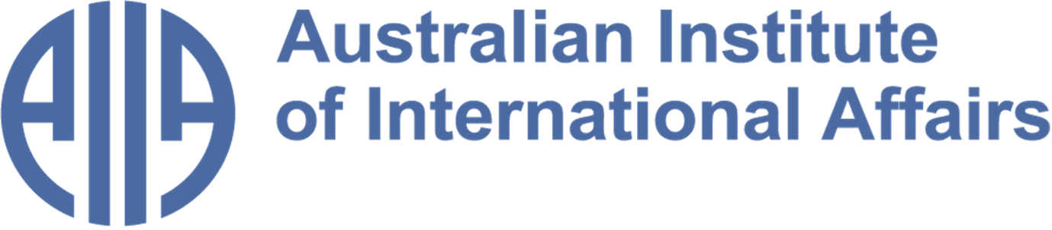

The Australian Institute of International Affairs New South Wales welcomes you to issue 115 of:

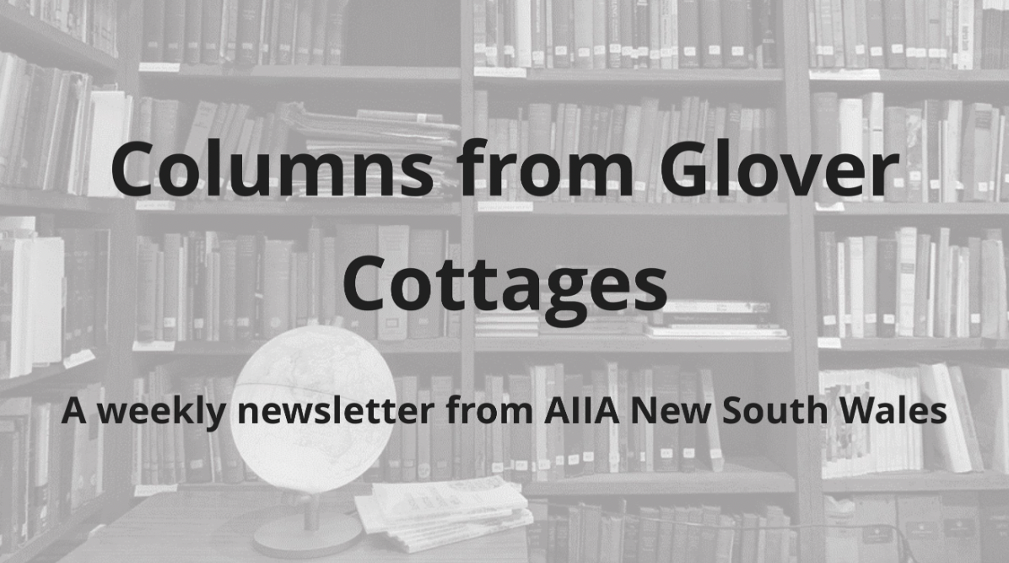

From the Councillors

​​Twice a month, some of our Councillors and interns share a selection of articles, analytical pieces, videos, and podcasts about what is happening in international affairs. This week Jocelyn Chey recommends a new history of Australia, and Lily Manning discusses the launch of James Curran's new biography on former Australian Prime Minister Paul Keating.
Disclaimer: The views expressed below by councillors and interns are their own. The Australian Institute of International Affairs New South Wales does not take policy positions.

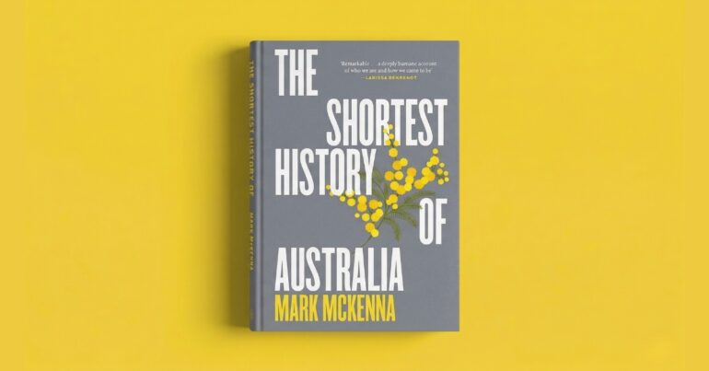

A Fresh View of Australia's Past, Present and Future
Most histories of Australia, including Manning Clark’s authoritative book, begin with the arrival of James Cook and develop a story of colonialisation and the construction of a political identity. Mark McKenna’s Shortest History of Australia takes a different approach. It rejects the narrative of progress and “turning points” with their inbuilt assumptions and substitutes a view of Australia as a continent, vast and complex, in an interconnected world. Those of us who are interested in international affairs would do well to start with such an understanding of “who we are”. In ten chapters/essays, McKenna explores the “founding lie” that Australia was “discovered”; the ancient art of Kakadu and northern Australia; European Pacific expeditions; expropriation of Indigenous lands; “war and memory”; “fire and water”; Federation and state identities; migration; relations with PNG and Indonesia; and other issues. This history is scholarly and well referenced. It is also concise and very readable.

Image credit: The Big Smoke.

This update was provided by Jocelyn Chey AM. Jocelyn is an Adjunct Professor at the Australia-China Relations Institute, University of Technology Sydney, Visiting Professor at the University of Sydney and an Adjunct Professor at the Australia-China Institute for Arts and Culture at Western Sydney University. She was previously a senior officer in the Department of Foreign Affairs and Trade. Jocelyn is a Fellow of the Australian Institute of International Affairs.

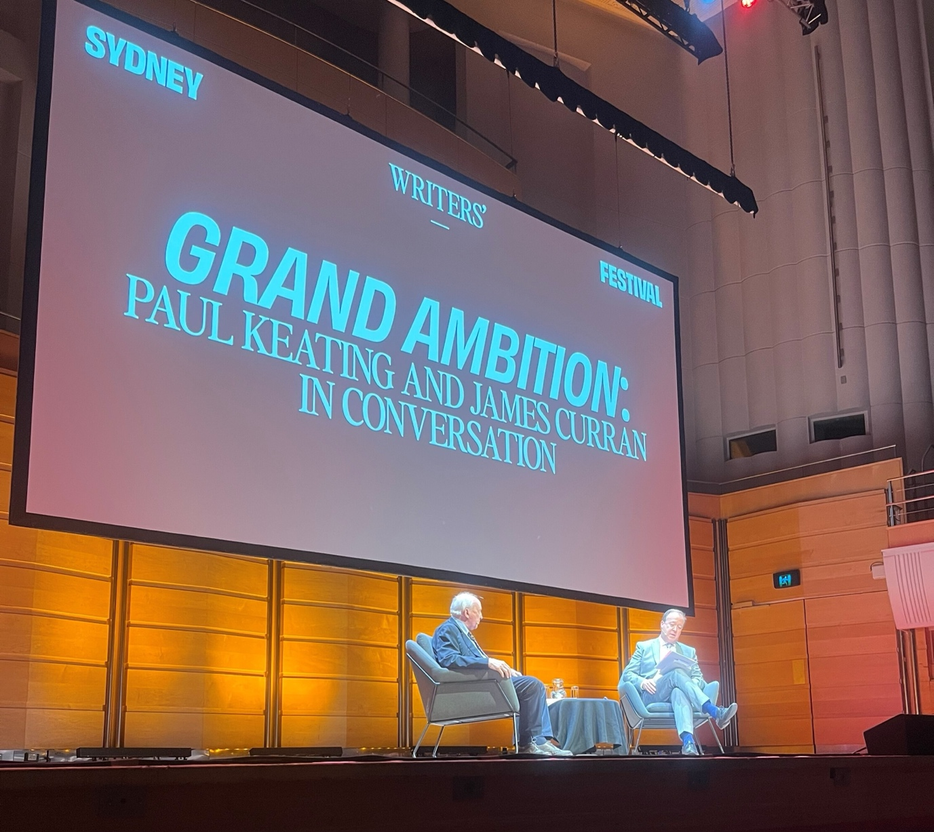

Grand Ambition: Paul Keating and James Curran in Conversation
If there is one piece of advice that former Australian Prime Minister Paul Keating has for young Australians, it is to maintain Australian sovereignty. Amid what Keating sees as an era of political timidity, where Australian leaders walk in foreign policy lockstep with the country's great and powerful friend, the US, Keating cautions that we risk losing the ability to "do things ourselves". This was the central theme of Keating's one-hour conversation with Sydney University Professor of Modern History, James Curran, at Sydney's City Recital Hall last week.
The event celebrated the launch of Curran's new biography Grand Ambition - a title that invokes Keating's imaginative vision of Australia's place in the world. The conversation spanned defining moments of his leadership, from his first month as Prime Minister, when he witnessed the collapse of the Soviet Union, to the rise of Australian republicanism, which he championed, and his role in developing APEC, which positioned Australia as a leading convening power in the region.
Curran gently probed Keating to recount memorable conversations with prominent figures of the time. From Queen Elizabeth II to General Suharto and President Bill Clinton, Keating recalled these interactions with a humour and acerbic wit that I had previously only seen in archived YouTube clips.
Importantly, Keating's vision of Australia as a country capable of shaping change and contributing meaningfully to regional prosperity remains alive. I am excited to get stuck into Curran's book.

This submission is written by Lily Manning. Lily Manning is a policy adviser at the Net Zero Economy Authority, working on clean energy investment and just transition policy. She holds First Class Honours in International and Global Studies from the University of Sydney and studied at Sciences Po Paris. She has contributed to publications including the Journal of the Indian Ocean Region and the United States Studies Centre, as well as ABC’s Four Corners.

From the Interns

In addition to our Councillors' recommendations, we invite our interns to share with you what they have found insightful or interesting in the world of international affairs. This week, Alexandra Kuo examines the impacts of geopolitics on Nepal's flood preparation, Mia Conway explores the 2021 US withdrawal from Afghanistan, and Jack Bettar investigates the politics of the Nile.
Disclaimer: The views expressed below by councillors and interns are their own. The Australian Institute of International Affairs New South Wales does not take policy positions.

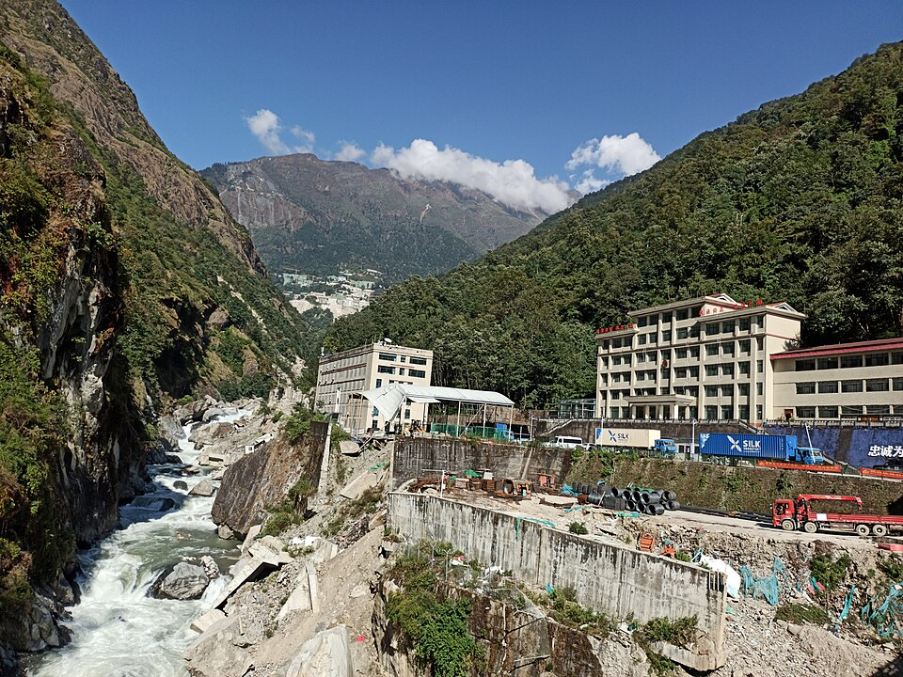
Floods in Nepal and Tibet: The Geopolitics of Disaster Warning
On 26 August, devastating flash floods hit the border between Nepal and the Chinese-controlled region of Tibet. While the exact death toll remains unclear, hundreds have been confirmed dead and many more remain missing. In an article for The Conversation, international relations academic Professor Dibyesh Anand argues that preparation for such natural disasters in the region is impeded by China’s control of Tibet. China heavily restricts access to Tibet, including the routine exclusion of journalists and researchers. Similarly, China views the data used to anticipate flooding as “strategically sensitive” according to Anand. Consequently, despite Nepal’s attempts to foster working relations with China, the country lacks reliable access to the information necessary to prepare for and mitigate the floods which commonly impact the area. In this case, warnings of the floods were inadequate. As climate change increases the likelihood of natural disasters, Anand emphasises the importance of cooperation between China and Nepal to strengthen disaster preparedness, so that Nepal’s ability to protect its people is no longer beholden to China’s security interests.
Image credit: Tatopani border between Nepal and Tibet via Wikimedia Commons.

This column was written by Alexandra Kuo. Alexandra is a third-year Law and Arts (International Relations) student at the University of Sydney. She has reached the finals of the World University Debating Championships which has interest in international affairs.

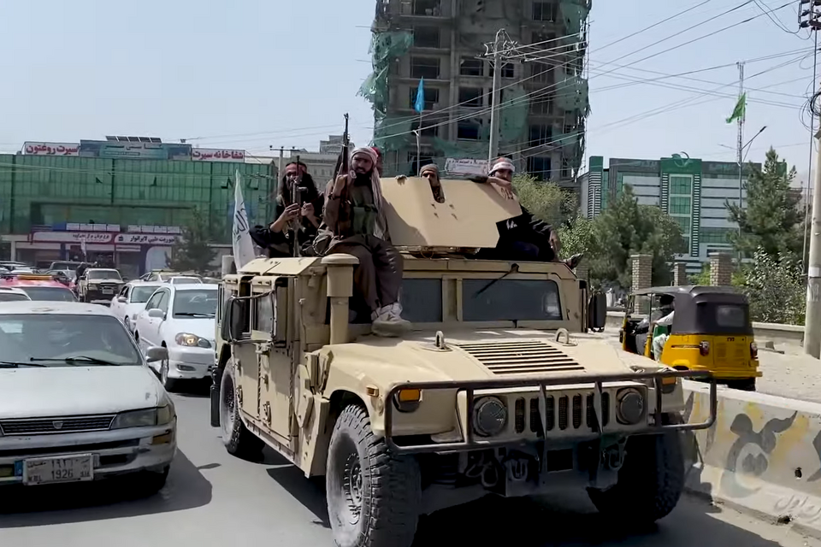
Five Years Since Go-to-Zero in Afghanistan
On the WSJ Opinion podcast Potomac Watch editor Paul Gigot and producer Michael Pack discuss "The Path to Zero," their documentary on the August 2021 Afghanistan withdrawal. Pack timed its release to the fifth anniversary of the Abbey Gate bombing, expecting the anniversary to prompt broad reflection though the occasion passed with little coverage.
Gigot and Pack frame the withdrawal as an avoidable catastrophe, recalling Biden's insistence on pulling every troop out - a decision that went against the recommendations of his advisors, who expressed concern about the hasty timeline. A cascade of failures followed, from abandoning Bagram, which forced a chaotic evacuation through Kabul's airport, to shifting State Department rules leaving Marines to make life-or-death choices at the gate. The documentary covers the soldiers' testimonies of moral injury and the lasting anguish of men who watched CIA-trained Zero Units kill civilians they could not save, a dimension that coverage at the time largely missed.
Gigot and Pack broaden the scope of their conversation, interpreting the withdrawal as the moment American deterrence collapsed and the United States signalled its weariness of distant wars. Their concern lies with the memory of Afghanistan itself, and how the version of the story presented by Western media often neglects the inhumane choices that soldiers were forced to make.
Image credit: Voice of America News, Taliban fighters in a captured Humvee after the Fall of Kabul on August 17 2021, via Wikimedia Commons

This column was written by Mia Conway. Mia is a fourth-year student completing a Bachelor of Social Sciences and a Diploma of Languages at the University of New South Wales. She currently researches for Protocol, a youth-led policy lab, in their technology and democracy team.

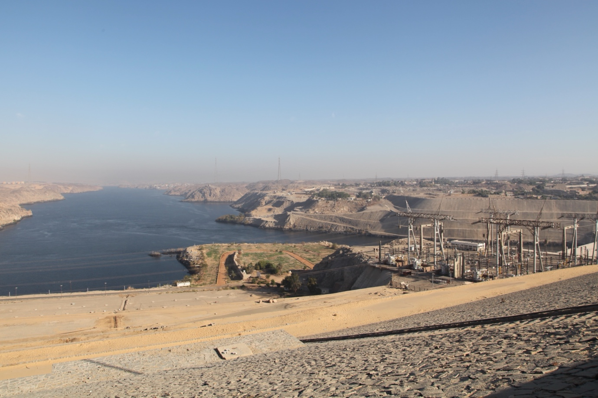

A River Divided
Herodotus is famously, though partly erroneously, attributed with the observation that “Egypt is the gift of the Nile”. For millennia, Egyptian administrations have relied upon the river to nourish their lands and sustain a growing population. Today, this dependence remains profound, making Egypt’s concerns over Ethiopia’s expanding control of the Nile an increasingly consequential geopolitical issue.
Reporting in The New Arab, Jonathan Fenton-Harvey observes that, a year after the controversial Grand Ethiopian Renaissance Dam (GERD) was inaugurated, Addis Ababa has advanced plans for three additional hydropower projects, costing more than US$10 billion. Ethiopia has shown little willingness to compromise, with its Water and Energy Minister asserting that no permission is required to develop the country’s water resources.
Egypt’s apprehension about the Nile’s ‘equitable use’ is understandable: 97% of its renewable freshwater resources derive from the river. The dispute raises broader questions about domestic development, regional cooperation and humanitarian pressures in Egypt and Sudan. It increasingly extends beyond water. Ethiopia’s pursuit of Red Sea access has prompted Egypt to strengthen military cooperation with Somalia and Eritrea, intertwining the Nile dispute with wider competition for regional influence. Ultimately, the future of the Nile may depend less on the dams themselves than their management. Transparency, information-sharing, coordinated water use and electricity trade could transform infrastructure into regional interdependence. Unilateralism, however, risks deepening an already volatile confrontation.
Image credit: Aswan High Dam (Egypt), built in 1970. Photo by author - January 2023.

This column was written by Jack Bettar. Jack is a Bachelor of Laws and Bachelor of Communications (Political and Social Sciences) student at the University of Technology Sydney. He has undertaken research and fieldwork in Egypt as part of a multidisciplinary expedition and has contributed to publications on the social and cultural history of the region.

What else we're reading

- Adam Curtis's Bitter Lake (2015) argues that Western politicians reduced militant Islam to a simplistic good-versus-evil story. Through newsreels and archive footage, it interweaves brief narration with prolonged sequences of war in Afghanistan.
- Writing for the BBC, Tim Whewell and Serhiy Solodko examine polarising discussions under way in the Ukrainian city of Odesa about banning the Russian language in the arts.
- The ABC reports that scientists are monitoring the unprecedented strength of the 2026 El Niño in the Pacific and how climate change may be intensifying it, as well as the severe impacts it will have in Australia and across the globe.
- In Pearls and Irritations former Ambassador to China Geoff Raby argues that ASEAN is taking a productive course of action by negotiating a rule of engagement with China on the South China sea but criticises the US, and by default Australia (and the Philippines), for focusing on military capacity in the region.
- Amid pervasive "Trump fatigue", New York Times journalists Maggie Haberman and Jonathan Swann's best-seller Regime Change offers fresh analysis and unprecedented access into the inner workings of the first two years of Trump's second presidency.
- The New Yorker's Isaac Chotiner interviews German-British historian Katja Hoyer to understand the rise of Germany's far-right AfD party against the backdrop of the country's Cold War history.

Upcoming Events

Intern debate: "AI is a force for global good"
Artificial intelligence has moved from the margins of policy discussion to its centre, reshaping economies, militaries, and societies at a pace few governments have been able to match. Its promise to solve intractable problems, from disease to economic development, sits uneasily alongside its capacity to displace workers and entrench authoritarian surveillance. As states, corporations, and civil society race to shape the future of this technology before it shapes them, this semester's interns take up one of the central questions of the debate over AI's place in the world.
Join us on Tuesday, 15 September, from 6pm, as our interns are set to debate this proposition, offering nuanced takes on the topic of AI and what the coming years and decades may hold for countries like Australia.
REGISTRATION CLOSES AT 4:00PM AEST ON Tuesday, September 15. We welcome participants in-person at the Glover Cottages, tickets to be pre-paid. Refreshments will be served from 6pm at Glover Cottages.

