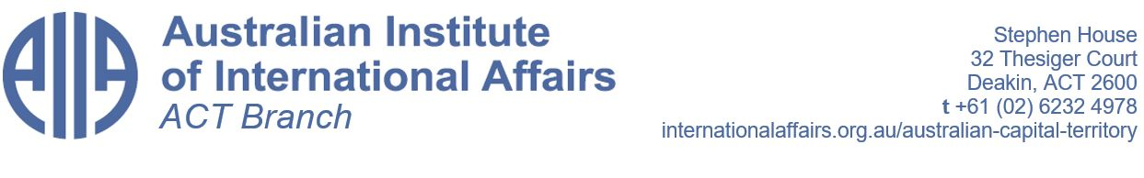
AGENDA
2023 Annual General Meeting
Thursday, 7 September 2023
Stephen House

1. Attendance

2. Welcome and apologies

3. Endorsement of the minutes of the previous meeting

4. Matters arising

6. President’s report

7. Treasurer’s report

8. Appointment of returning officer

9. Election of the 2023/2024 Council

10. Appointment of auditor

11. Appointment of public officer

12. Lodgement of annual return of regulatory services

13. General business

