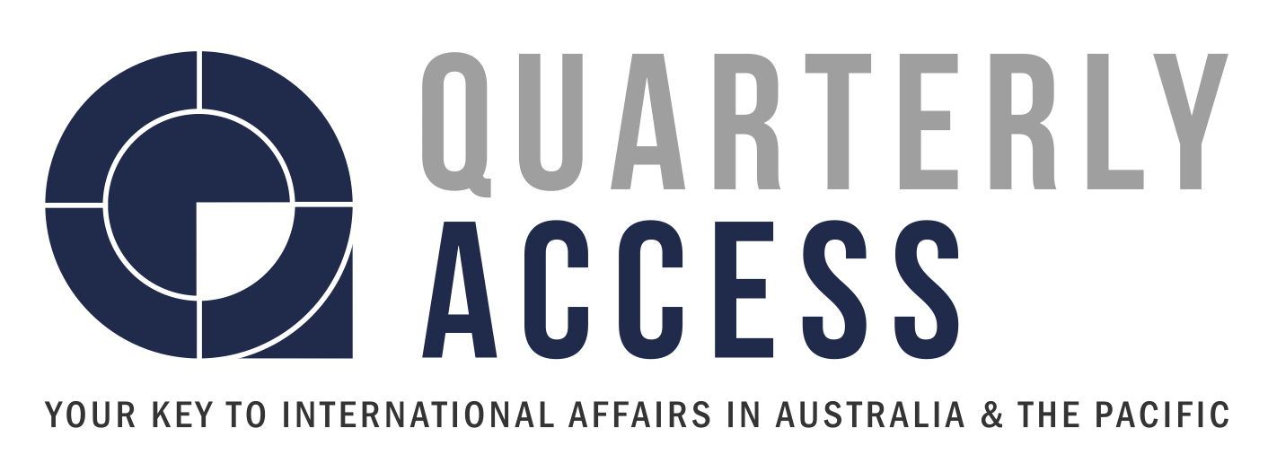

Social Media Officer — POSITION DESCRIPTION

ABOUT Quarterly Access

Quarterly Access (QA) is the national publication of the youth networks of the Australian Institute of international Affairs. It is an entirely volunteer based publication providing opportunity for students and young professionals to publish in-depth high-quality articles on global issues of importance. We aim to help inform and foster debate amongst a new generation of leaders.

ABOUT THE ROLE

The Social Media Officer will be responsible for managing QA Facebook, Twitter and other social media accounts. You will help design and lead social media campaigns, nurture and grow audience engagement and assist in implementing the social media strategy for 2017. The successful applicant will have a background in communications and/or media, will be creative and innovative when it comes to audience engagement. You will also know how to drive the numbers of followers and subscribers.

Applicants must be aged between 18 and 30 years.

KEY INFORMATION

Title: Social Media Officer
Length of appointment: 12 months (3 month probation period)
Reports to: Editor-in-Chief
Commitment: 1- 6 hours per week, with a slight increase during peak periods
Role type: Voluntary — volunteers will not be remunerated for their time

ROLES AND RESPONSIBILITIES

Task | Description | % of role
Social Media Management | - Copy-editing and preparing posts on Facebook, Twitter, LinkedIn, and possibly new media outlets  - Audience growth engagement - Comment monitoring and fostering debate  - Social media campaign design and leadership  - Scheduling and management for consistent and regular engagement  - Confidently implement the tone of QA throughout different Social Media outlets | 65%
Editorial | - Attend editorial committee meetings (either in person or via skype) | 20%
Communication | - Regularly communicate with Editorial Committee online via email and Facebook  - Draft emails to subscribers and authors/contributors as required | 10%
Other duties as reasonably required | - Attend AIIA events as required | 5%

KEY SKILLS, KNOWLEDGE AND ABILITIES

- Demonstrated knowledge of and interest in international affairs
- Relevant academic background
- Outstanding written communication skills
- Confidence in liaising with editorial committee, authors/contributors, and general public
- Excellent time management skills
- Strong attention to detail
- Proficiency in MS Office, Google Drive, Twitter, LinkedIn, Facebook (analytics)
- Ability the build and maintain relationships
- Ability to design and implement social media campaigns and strategies

DESIRABLE SKILLS, KNOWLEDGE AND ABILITIES

- Previous experience in editing and/or publishing.
- Experience in social media/communications role.

OTHER CRITERIA

Applicants must be:

- Between 18 and 30 years of age

INTERESTED?

To apply, please email your CV and a cover letter addressing why you would be perfect for this role by 11:59 pm on Friday 28th April, 2017 to quarterlyaccess@gmail.com with the subject line EOI: Social Media Officer

Your application should include the following:

- CV
- Cover letter

Shortlisted candidates will be contacted for an interview.

