Registration Instructions:
- Under “Available Tickets” check the appropriate ticket option
- Click “Continue” to proceed to the next page
- After filling in the form, click “Continue” again
- Scroll down and click the “Buy Now” icon in the bottom right hand corner of the page
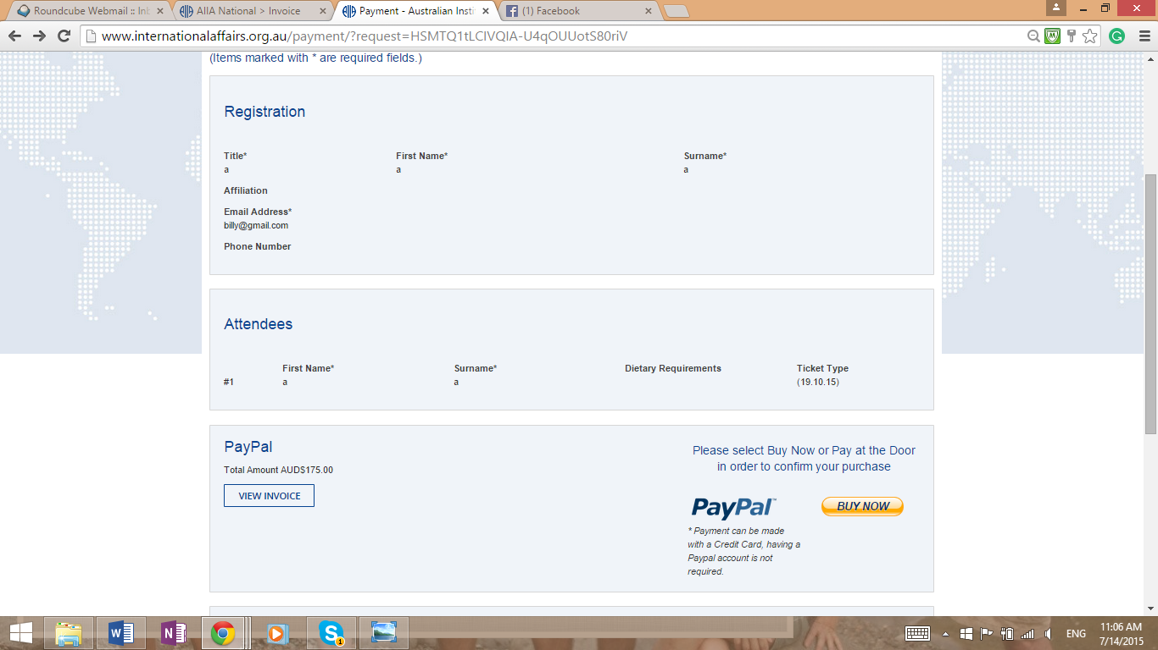

- You can now pay with PayPal account or pay with a credit or debit card
- Fill out the required details and click “Pay” at the bottom of the page.
- You will receive a confirmation email from PayPal

